

DEBRE BERHAN UNIVERSITY
COLLEGE OF COMPUTING
DEPARTMENT OF DATA SCIENCE
HIV/ART RISK PREDICTION AND
CLINICAL INTELLIGENCE DASHBOARD

An Internship Report Submitted to the Department of Data Science in Partial Fulfillment of the Requirements for the Bachelor of Science Degree in Data Science

Prepared by | Rahel Genene (ID: 1601570)  Hanna Getachw (ID: 1601241)
Host Organization | Ministry of Health, Ethiopia
University Supervisor | Mr.Gebremedhin Desta
Internship Supervisor | __Mr Amsayaw__________________
Internship Period | June 8 – August 8, 2026

Debre Berhan, Ethiopia | 2026

Approval Sheet
This internship report is submitted for the Bachelor of Science degree in Data Science, Department of Data Science, College of Computing, Debre Berhan University, by the student team named below. It has been checked and approved by the people below.

Role | Name | Signature | Date
Prepared by | Rahel Genene
Prepared by | Hanna Getachw
Reviewed by
Reviewed by
Department Head
Declaration
Rahel Genene and Hanna Getachw declare that this report is our own work. As a team, we collected and cleaned the data, built the models, and built the dashboard ourselves, with guidance from our internship supervisor at the Ministry of Health, Ethiopia. The primary HIV/ART dataset used in this project came from the Armauer Hansen Research Institute (AHRI). We did not copy this report from any other student or source, and we have not submitted it anywhere else for credit. Where we used an AI tool to help organize or polish our writing, we checked every fact and number ourselves against our own notebooks and results before including it here.

Student Name: Rahel Genene Signature: ____________________
Student Name: Hanna Getachw Signature: ____________________
Date: ____________________________
Acknowledgement
We want to thank the Ministry of Health, Ethiopia, for hosting our internship and giving us real projects to work on. We are grateful to our internship supervisor and the wider supervising team for guidance throughout the internship, and for pointing us toward the AHRI dataset that our main project is built on. We also thank the Department of Data Science at Debre Berhan University for the coursework that prepared us for this internship. Finally, we thank our families and classmates, who supported us during the two months of this internship.
We would also like to thank each other. Completing a project of this scope as a two-person team required trust in each other's work at every stage, from cleaning code neither of us had written alone to a dashboard section built by one of us and tested by the other. We think the final result reflects that partnership throughout, and we are grateful for it.
Abstract
This report describes a two-month internship completed by Rahel Genene and Hanna Getachw at the Ministry of Health (MoH), Ethiopia, from June 8 to August 8, 2026. As a team, we were assigned to MoH's digital health function, where we learned how the Ministry manages national health information systems and dashboards, including its use of DHIS2 (District Health Information System 2) for routine health reporting and monitoring, and gained hands-on exposure to KoboToolbox and REDCap as data collection platforms. Access to complete, real-world operational health datasets was limited during the internship, due to data confidentiality requirements and the approval processes needed to release facility-level data, so our main technical project used an HIV/ART patient dataset obtained from the Armauer Hansen Research Institute (AHRI), a leading public health and biomedical research institution that manages high-quality research datasets in support of disease surveillance, monitoring, and evidence-based decision-making.
Our main project, the Machine Learning-Based HIV/ART Risk Prediction and Clinical Intelligence Dashboard, carried the AHRI dataset (2,506 patients, 833 raw columns, 72.1% of cells empty) through a full data science pipeline: data cleaning, feature engineering, exploratory analysis, machine learning modeling, and R Shiny dashboard development. After cleaning, fixing patient identifiers, and removing 28 duplicate records, we trained and compared four models Decision Tree, Random Forest, Support Vector Machine, and Gradient Boosting on two outcome definitions, with Random Forest performing best in both cases (cross-validated ROC-AUC of about 0.80 for a death-only outcome and 0.71 for a broader unfavorable-outcome definition). Our R Shiny dashboard presents Viral Load, CD4, Risk Level, Retention Status, and Facility Performance indicators to support clinical monitoring and decision-making. This report explains, as a team, what we did, what we found, and what we would improve if given more time.
Table of Contents
Approval Sheet ii
Declaration iii
Acknowledgement iv
Abstract v
List of Tables viii
List of Figures ix
List of Abbreviations x
CHAPTER ONE: INTRODUCTION 1
1.1 Background 1
1.2 Internship Objectives 2
1.3 Scope of Internship 3
1.4 Methodology 3
1.5 Report Structure 4
CHAPTER TWO: ORGANIZATION PROFILE 5
2.1 Ministry of Health Overview 5
2.2 Digital Health Systems in Ethiopia 6
2.3 DHIS2 Platform 6
2.4 AHRI Overview 7
2.5 Relationship Between MOH and AHRI 8
2.6 Data Flow Architecture 8
2.7 Digital Health Transformation 9
CHAPTER THREE: INTERNSHIP ACTIVITIES 10
3.1 Orientation and Training 11
3.2 DHIS2 Exposure 11
3.3 KoboToolbox Activities 12
3.4 REDCap Activities 13
3.5 Dashboard Development 13
3.6 Machine Learning Activities 14
3.7 Weekly Reflection 16
CHAPTER FOUR: PROJECT IMPLEMENTATION 19
4.1 Project Background 19
4.2 Problem Statement 20
4.3 Project Objectives 20
4.4 Project Methodology Framework 22
4.5 Data Description 22
4.6 Data Preprocessing 23
4.7 Exploratory Data Analysis 26
4.8 Feature Engineering 28
4.9 Machine Learning Models 29
4.10 Model Evaluation 30
4.11 Dashboard Development 31
4.12 Results and Discussion 33
CHAPTER FIVE: CHALLENGES AND LESSONS 37
5.1 Data Access Challenges 37
5.2 Technical Challenges 38
5.3 Lessons Learned 39
5.4 Skills Acquired 40
CHAPTER SIX: CONCLUSION AND RECOMMENDATIONS 41
6.1 Conclusion 41
6.2 Key Achievements 42
6.3 Learning Outcome Reflection 42
6.4 Recommendations 44
6.5 Future Work 45
REFERENCES 47
APPENDICES 48
Appendix A: Dashboard Screenshots 48
Appendix B: Data Cleaning Workflow 48
Appendix C: Model Evaluation Results 49
Appendix D: Sample Code Snippets 49
Appendix E: Internship Schedule 50
Appendix F: Team Contribution Summary 51
Appendix G: Glossary of Terms 51
List of Tables
Table 3.1: Weekly summary of internship activities.
Table 4.1: Feature set used for risk prediction.
Table 4.2: Model comparison — death-only outcome.
Table 4.3: Model comparison — unfavorable-outcome target.
Table 4.4: Data quality before and after cleaning.
Table 4.5: Facility-level unfavorable-outcome rates.
Table 5.1: Data access challenges and solutions.
Table C.1: Model comparison — death-only outcome.
Table C.2: Model comparison — unfavorable-outcome target.
Table D.1: Sample data dictionary for key cleaned fields.
Table E.1: Internship schedule.
Table F.1: Team contribution summary.
Table F.2: Weekly primary focus and lead, by team member.
List of Figures
Figure 4.1: Project methodology framework.
Figure 4.2: CD4 trend direction among patients with repeat testing.
Figure 4.3: Viral load suppression rate per patient and by visit number.
Figure 4.4: Patient outcome distribution (retained, lost to follow-up, died).
Figure 4.5: Patient age distribution and age by outcome.
Figure 4.6: WHO clinical stage distribution and unfavorable-outcome rate by stage.
Figure 4.7: Correlation matrix of key numeric variables.
Figure 4.8: Patient sex distribution and outcome by sex.
Figure 4.9: Feature importance for the corrected Random Forest mortality model.
Figure 4.10: Unfavorable-outcome rate by facility, for the eight largest facilities.
Figure A.1: Executive Summary view of the deployed R Shiny dashboard (Appendix A).
List of Abbreviations
AHRI — Armauer Hansen Research Institute
ART — Antiretroviral Therapy
AUC — Area Under the Curve
BMI — Body Mass Index
CD4 — Cluster of Differentiation 4 (a type of white blood cell used to measure immune system strength)
CEM — the name of the patient dataset used in the main project
CV — Cross-Validation
DBU — Debre Berhan University
DHIS2 — District Health Information System 2
EPHI — Ethiopian Public Health Institute
F1 — F1 Score (a single number that balances precision and recall)
HIV — Human Immunodeficiency Virus
KPI — Key Performance Indicator
MoH — Ministry of Health
REDCap — Research Electronic Data Capture
ROC — Receiver Operating Characteristic
SVM — Support Vector Machine
WHO — World Health Organization

CHAPTER ONE: INTRODUCTION
1.1 Background
Internship is a required part of the Bachelor of Science in Data Science program at Debre Berhan University. It gives students a chance to use what they learned in class on a real problem, inside a real organization. We working together throughout the internship period. Working as a team, rather than individually, shaped how we approached this internship from day one: we divided technical work where it made sense to divide it, reviewed each other's cleaning and modeling decisions before treating them as final, and kept a shared, consistent set of files and results so that either of us could pick up any part of the project at any time.
Ethiopia's health system collects a huge amount of data every day, from individual health facilities up to national reporting platforms, but collecting data is not the same as using it well. This report is about our internship at the Ministry of Health (MoH), Ethiopia, the national authority responsible for health policy, digital health initiatives, disease monitoring, and the country's health information systems. MoH manages and coordinates national health information systems, including DHIS2 (District Health Information System 2), one of the major systems used for health reporting and monitoring. Regional Health Bureaus, hospitals, health centers, the Ethiopian Public Health Institute (EPHI), AHRI, and other health programs all contribute data to these national systems, and MoH increasingly uses data-driven decision-making approaches through dashboards and reporting tools built on top of this data.
During our internship, we learned how MoH manages these digital health systems and dashboards, and we observed how DHIS2 is used for routine health reporting and monitoring. However, obtaining complete, real-world operational health datasets directly from MoH's production systems during the internship was difficult, due to data access restrictions and confidentiality requirements. Because of this, our main technical project used an HIV/ART patient dataset obtained from the Armauer Hansen Research Institute (AHRI), a leading public health and biomedical research institution that manages high-quality research datasets in support of public health research, disease surveillance, monitoring, and evidence-based decision-making.
CD4 count, viral load, and WHO clinical stage are the main indicators clinicians use to check how an HIV patient is doing on treatment. If a dataset like this is cleaned properly, these indicators can be used to build a model that flags patients who may need extra attention. That is the idea our main project was built around.
1.2 Internship Objectives
General Objective: Learn how MoH manages digital health information systems, and to apply data science and machine learning techniques to a real HIV/ART dataset, producing a cleaned dataset, a risk-prediction model, and an R Shiny dashboard consistent with MoH's digital health environment.
We set this general objective deliberately broad enough to cover both halves of the internship the organizational learning about how MoH's digital health systems work, and the hands-on technical project because we did not want to treat either half as secondary to the other. The specific objectives below break this general objective down into concrete, checkable pieces, most of which map directly onto a specific chapter or section later in this report.
Specific Objectives:
- Learn how MoH's digital health systems, including DHIS2, are used for national health reporting and monitoring.
- Gain hands-on exposure to other digital health platforms used across the sector, including KoboToolbox and REDCap.
- Check the quality of the AHRI HIV/ART dataset and find out how much data was missing and why.
- Clean the demographic, clinical, laboratory, geography, and medication fields.
- Fix the patient identifier problem and remove duplicate patient records.
- Build a clear set of features and a proper outcome label for prediction.
- Train and compare four machine learning models for risk prediction.
- Build an R Shiny dashboard presenting Viral Load, CD4, Risk Level, Retention Status, and Facility Performance indicators.
- Write up our data quality findings, model results, and what they mean for patient care and program monitoring.
1.3 Scope of Internship
The internship lasted about nine weeks, from June 8 to August 8, 2026, inside MoH's digital health team. During this time we, as a team, were exposed to MoH's broader digital health environment, including DHIS2, and contributed to the R Shiny dashboard described in this report. Our main hands-on technical project was centered on one dataset: the AHRI-collected CEM export, 2,506 patients and 833 columns. Our work covered the full path from raw data to a working dashboard prototype. It did not include connecting to MoH's live production systems, working on diseases other than HIV in our main project, or making clinical decisions those stayed with MoH's clinical staff.
We also want to be explicit about what was outside our scope, since a clear boundary is as important to a report like this as a clear list of what was included. We did not have authority to change how data is collected at the facility level, we did not have access to patient data beyond the AHRI dataset we were given, and none of our outputs were used for an actual clinical decision during the internship period every result in this report is a prototype finding, intended to demonstrate feasibility, not a validated clinical tool.
1.4 Methodology
We started with orientation to MoH's digital health systems and to how R Shiny dashboard tools are set up within MoH's environment, so the dashboard we built would fit into that environment rather than sit apart from it. After that, we worked in stages: understand the data, clean it, engineer features, build models, then build the dashboard. As a team, we divided and shared this work, and after each stage we checked in with our internship supervisor before moving to the next one. We kept our notebooks and scripts organized so that anyone on the team, or anyone reviewing our work, could re-run our cleaning steps and get the same result.
We also kept a simple rule for ourselves throughout the internship: never report a result we could not explain. If a chart looked surprising, we went back and checked the underlying data before trusting it. This rule is what caught the subcity-grouping issue described in Chapter Four, and it shaped how carefully we checked our own work at every stage, not only at the end.
Where our approach changed mid-internship — most notably, the outcome-target redefinition described in Chapter Four — we have tried to document both the original approach and the revised one, rather than only presenting the final version as though it were our plan from day one. We think this honesty about how the project actually unfolded is itself part of a sound methodology, not a departure from it.
1.5 Report Structure
Chapter One introduces the internship and our team. Chapter Two describes the Ministry of Health, Ethiopia's digital health systems, AHRI, and how the two relate. Chapter Three walks through our internship activities and the digital health platforms we learned, organized by topic. Chapter Four is the main technical chapter, covering our HIV/ART risk-prediction project from problem statement through results. Chapter Five discusses the challenges we faced and the lessons we learned. Chapter Six closes the report with our conclusion and recommendations. The appendices provide dashboard screenshots (Appendix A), the data cleaning workflow (Appendix B), model evaluation results (Appendix C), sample code snippets and a data dictionary (Appendix D), the internship schedule (Appendix E), the team contribution summary (Appendix F), and a glossary of terms (Appendix G).
We have written this report in plain, professional English throughout. Where a technical term is unavoidable (such as ROC-AUC or DHIS2), we explain it in plain words the first time it appears, and we also collect these explanations together in the Glossary of Terms in the appendices.
CHAPTER TWO: ORGANIZATION PROFILE
2.1 Ministry of Health Overview
The Ministry of Health (MoH) is Ethiopia's national authority responsible for health policy and digital health systems. MoH sets national health policy, coordinates public health programs including HIV/AIDS prevention, treatment, and care and leads the country's digital health transformation. MoH manages and coordinates national health information systems, working with Regional Health Bureaus, hospitals, health centers, the Ethiopian Public Health Institute (EPHI), AHRI, and other health programs, all of which contribute data to national systems that MoH oversees. Increasingly, MoH uses data-driven decision-making approaches, relying on dashboards and reporting systems to turn this data into something program managers and clinicians can act on quickly.
As a national ministry, MoH's responsibilities extend well beyond any single disease program. It sets the overall direction for how health data is collected, standardized, and shared across a large and varied health system, ranging from small rural health posts to major national referral hospitals. This means that any digital health tool built for MoH, including the dashboard described later in this report, has to be designed with that variety in mind a tool that only works for one kind of facility, or assumes perfectly complete data, is of limited use across a system this broad.
MoH's digital health function is organized around a mix of permanent technical staff and rotating project teams, often supplemented, as in our case, by university interns contributing to specific, time-bound deliverables. This structure means that a well-scoped internship project one with a clear dataset, a clear deliverable, and a realistic timeline can genuinely contribute to MoH's broader digital health goals, even though it is completed in a matter of weeks rather than months or years. We tried to design our own project with this in mind, aiming for something complete and usable within our nine weeks, rather than an ambitious but unfinished system.
The team we worked with is part of MoH's broader digital health effort, where different small teams are each responsible for turning a specific kind of health data into something usable. our own contribution to this effort is described in detail in Chapters Three and Four.
2.2 Digital Health Systems in Ethiopia
Ethiopia's health sector has invested heavily in digital health over the past decade, moving many reporting and monitoring processes from paper to electronic systems. This includes routine service-delivery reporting, disease surveillance, survey-based data collection, and dashboards and analytics tools that turn raw reports into something decision-makers can use quickly. MoH leads this digital health transformation at the national level, working with regional health bureaus, EPHI, and research and development partners to keep these systems running and to expand what they can do.
This shift has not happened all at once, and it has not happened evenly. Some programs, particularly routine service reporting through DHIS2, are relatively mature and well established. Others, including many research cohorts and facility-specific monitoring efforts, still rely heavily on spreadsheets, paper registers, or platform-specific tools like REDCap and KoboToolbox that were not originally designed to talk to each other. Part of what made our internship instructive was seeing this unevenness first-hand: our own project sat closer to the less mature end of that spectrum, working with a research dataset rather than a fully integrated national system, which is precisely why the data-cleaning work described in Chapter Four was so extensive.
2.3 DHIS2 Platform
DHIS2 (District Health Information System 2) is one of the major systems MoH uses for health reporting and monitoring, and it serves as the backbone of Ethiopia's national health information system. Health facilities and programs enter routine service data into DHIS2 such as patient counts, immunizations given, and disease case counts which is then aggregated up through district, regional, and national levels. MoH and regional health bureaus use DHIS2 to monitor health program performance, track targets, and support decisions about where resources are most needed. During our internship, we were exposed to how DHIS2 dashboards are used for this kind of program management and decision-making, which gave us useful context for designing our own dashboard, even though our main project used a separate, AHRI-sourced dataset rather than data drawn directly from DHIS2.
What stood out to us most about DHIS2, compared to the research-oriented tools we used for our main project, is its emphasis on standardization across a very large number of contributors. Thousands of facilities enter data into the same platform, using the same indicator definitions, which is what makes national-level aggregation possible in the first place. This is a very different design goal from REDCap, which is built around a single research team's specific data-collection needs, or KoboToolbox, which is built around flexible, one-off field surveys. Seeing all three platforms during the same internship helped us understand that there is no single "correct" way to build a health data system the right tool depends on whether the priority is national-scale standardization, research-grade data quality, or field-level flexibility.
2.4 AHRI Overview
The Armauer Hansen Research Institute (AHRI) is a leading public health and biomedical research institution based in Addis Ababa. AHRI conducts public health and clinical research, including work on HIV/AIDS, tuberculosis, and other infectious diseases, and manages high-quality research datasets in support of this work. AHRI supports public health research, disease surveillance, monitoring, and evidence-based decision-making, both through its own research activities and through partnerships with organizations such as MoH.
As explained further in Chapter Five, we used an AHRI HIV/ART dataset for our main project because obtaining operational health datasets directly from MoH during the internship was difficult, due to access restrictions and confidentiality requirements that rightly govern real patient data. AHRI's dataset, collected and managed as part of a formal research process, gave us an appropriately governed, high-quality dataset to work with instead.
It is worth being clear about what "research-grade" means in this context, since it is easy to assume it means "already clean." AHRI's data collection process follows research protocols and ethical oversight appropriate for a formal study, which governs who may access the data and for what purpose — but, as Chapter Four describes at length, it does not mean the data arrives free of the ordinary messiness of real-world data entry. Research governance and data cleanliness are two separate things, and our project needed to address both.
2.5 Relationship Between MOH and AHRI
MoH and AHRI work together as part of Ethiopia's broader health research and information ecosystem: AHRI conducts and manages specific research studies and cohorts, while MoH uses evidence from institutions like AHRI, alongside its own routine data systems such as DHIS2, to inform national policy and program decisions. For our internship, this relationship is what made our main project possible in the first place being hosted at MoH gave us the organizational context and guidance to work with an appropriate AHRI research dataset, under the same expectations of care and confidentiality that would apply to any patient data.
From our vantage point as interns, this relationship also illustrated a broader pattern worth naming: national ministries and research institutions each hold different, complementary strengths. MoH has reach across the entire health system and the authority to set standards and policy; AHRI has the depth of research infrastructure needed to run a well-governed, detailed patient cohort. Neither could easily substitute for the other, and our own project hosted by one, built on data from the other was a small, concrete example of how that complementary relationship plays out in practice.
2.6 Data Flow Architecture
Health data in Ethiopia's system generally flows in stages: a patient encounter is recorded at a health facility, either on paper or in an electronic tool such as REDCap or KoboToolbox; facility-level data is then aggregated and reported upward, often into DHIS2, at the district, regional, and national levels; and research institutions such as AHRI may separately collect and manage cohort-level research data, sometimes drawing on the same underlying facilities, under their own data governance processes. MoH sits at the center of this architecture, coordinating standards and systems across these different data sources, even though each source (routine reporting through DHIS2, survey data through KoboToolbox, and research cohorts through REDCap) is collected and managed somewhat differently. Understanding this architecture helped us see why our own dataset sourced from AHRI rather than pulled directly from a live MoH system was a reasonable and realistic starting point for a project like ours.
One consequence of this layered architecture, which we saw directly in our own dataset, is that the same underlying fact about a patient can end up recorded slightly differently depending on which system captured it and when. A subcity name typed freely into a REDCap form will not automatically match the standardized subcity list used in a DHIS2 report, even though both describe the same real place. Recognizing this as a structural feature of the data flow, rather than a one-off mistake by whoever entered the data, changed how we approached cleaning: we treated inconsistency as the expected starting condition, not an exception to work around.
2.7 Digital Health Transformation
MoH's digital health transformation agenda aims to make health data more complete, more timely, and easier to act on, across every level of the system described above. Dashboards, like the one described in this report, are one visible part of that agenda: they take data that already exists whether from DHIS2, KoboToolbox, or a research dataset like AHRI's and present it in a form that a program manager or clinician can use without needing to process raw exports themselves. Our internship placed us directly inside this effort, giving us a chance to contribute a working example of this kind of tool rather than only studying it.
We also came to see digital health transformation as something that happens unevenly, one dataset and one workflow at a time, rather than as a single, sweeping change. Our own project is a small illustration of that pattern: it did not transform how MoH manages HIV/ART data nationally, but it did demonstrate, end to end, what turning one messy dataset into one usable tool actually requires the data-quality work, the modeling decisions, and the design choices described in the chapters that follow. We think this kind of small, complete demonstration has real value alongside larger, system-wide initiatives, because it shows concretely what a finished piece of the transformation looks like.
CHAPTER THREE: INTERNSHIP ACTIVITIES
This chapter describes the practical work we completed during the internship, organized by topic, and the digital health platforms and technologies we learned along the way. A week-by-week schedule is also provided in the appendices for quick reference.
Table 3.1 summarizes the internship week by week, using the same eight periods as the full internship schedule in Appendix E, and Section 3.7 reflects on each of them. The table follows the main project stream; the DHIS2, KoboToolbox, and REDCap exposure described in Sections 3.2 to 3.4 continued alongside it.
Table 3.1: Weekly summary of internship activities.
Week | Learning Objectives | Major Activities | Deliverables | Skills Acquired
1  Jun 8–14 | Understand MoH's role and digital health team; learn access and confidentiality expectations; obtain a project dataset. | Orientation to MoH and its R Shiny dashboard setup; requesting access to tools and datasets; obtaining the AHRI HIV/ART dataset. | Access to the AHRI dataset (2,506 patients, 833 columns). | Working within data-confidentiality expectations; handling access requests.
2  Jun 15–28 | Measure how much of the raw data was missing, and why. | Data quality assessment of the raw 2,506 × 833 file; review of the 386 columns that were more than 95% empty. | Missing-data findings: 72.1% of cells empty and 121 fully empty columns. | Separating expected missingness from real data gaps through manual spot-checks.
3  Jun 29–Jul 12 | Clean the demographic and clinical fields. | Cleaning of age (94 text formats), WHO clinical stage, weight, height, and BMI. | Cleaned age, WHO stage, and BMI fields (for example, age_cleaned.csv). | Standardizing free-text fields; recalculating BMI instead of trusting the original column.
4  Jul 13–21 | Standardize geography and medication data, reshape lab results, and build a reliable patient identifier. | Three-round subcity cleaning; ART regimen standardization; lab reshaping from wide to long; patient ID reconstruction and de-duplication (148 collisions narrowed to 28 true duplicates). | De-duplicated dataset of 2,478 patients (CEM_deduped.csv); long-format lab table of 40,268 test records. | Conservative duplicate detection, with peer review of merge decisions.
5  Jul 22–28 | Build the modeling table and a first predictive model. | Feature preparation; training and comparing models on the death-only target (110 of 2,478 patients, 4.44%). | First mortality model (Random Forest, cross-validated ROC-AUC 0.825). | Handling a rare-event target with class weights; reading precision and recall alongside accuracy.
6  Jul 29–Aug 3 | Explore the cleaned data fully and choose a more usable prediction target. | Exploratory analysis of outcomes, age, WHO stage, sex, and CD4 and viral load trends; target redefined, after discussion with the internship supervisor, as death or loss to follow-up. | Exploratory figures; redefined unfavorable-outcome target (40.72% event rate); Random Forest precision 0.543 and test ROC-AUC 0.712. | Reporting a weak result honestly and changing the problem definition rather than over-tuning the model.
7  Aug 4–6 | Turn the model results into an interactive tool that fits MoH's R Shiny environment. | Dashboard built first in Python and then in R Shiny; the four models re-implemented in R. | Five-tab R Shiny dashboard (Executive Summary, Cohort Explorer, Risk Assessment, Facility Performance, Data Quality). | R Shiny development with live model training; mirroring a Python pipeline in R.
8  Aug 7–8 | Verify the dashboard and hand over the results. | Checking on-screen numbers against the notebooks; testing filters and patient profiles; cold-use review of each tab by the teammate who had not built it; writing up results. | Tested dashboard and written results for handover to MoH. | Usability testing; explaining a technical trade-off to a non-technical supervisor.

3.1 Orientation and Training
We began the internship with orientation to MoH as an organization: its role as the national health authority, how its digital health team is structured, and how R Shiny-based dashboard tools are typically set up within MoH's environment. This orientation helped us understand what our own dashboards would need to fit into later, and it gave us the organizational context described in Chapter Two. We were also introduced to the broader health information workflow how data moves from a patient encounter at a facility, up through reporting systems, to the dashboards decision-makers actually use.
Orientation also covered practical, day-to-day expectations: how to request access to specific tools and datasets, who to contact with a technical question versus a data-access question, and what MoH's expectations were around confidentiality when working with any health-related information, even data that was not itself patient-identifiable. We found this grounding valuable throughout the internship, well beyond the first week, since it gave us a consistent reference point whenever a new question came up about what we could and could not do with a given piece of data.
3.2 DHIS2 Exposure
Purpose
DHIS2 exists to give Ethiopia's health system one common platform for routine health reporting, so that data from thousands of facilities can be aggregated, compared, and acted on at the district, regional, and national level.
Reporting Workflow
We observed how facility-level data is entered, validated, and aggregated upward through DHIS2, and how discrepancies or missing reports are flagged for follow-up at higher administrative levels.
Health Monitoring
We saw how MoH and regional health bureaus use DHIS2 dashboards to monitor program performance against targets, and how this kind of routine monitoring differs from the one-off, research-style analysis we carried out on our own AHRI dataset. Routine DHIS2 monitoring is built to answer recurring, standardized questions is this district on track against its immunization target this month while our own analysis was built to answer a one-time, exploratory question about a fixed research dataset. Seeing both approaches side by side helped us appreciate that "data analysis" in a health setting is not one single activity, but several different ones with different tools, timelines, and audiences.
3.3 KoboToolbox Activities
Data Collection
We learned how KoboToolbox is used to collect structured data directly from the field, often in settings where a full REDCap or DHIS2 deployment is not practical.
Mobile Surveys
We saw how field staff use the KoboToolbox mobile app to collect survey responses on a phone or tablet, including in areas with limited or intermittent internet connectivity, with responses syncing once a connection is available.
Form Management
We were introduced to KoboToolbox's form-builder, used to design structured questionnaires with validation rules, skip logic, and multiple question types.
Data Export
We learned how data collected in KoboToolbox can be exported as spreadsheets, or accessed via its API, for cleaning and analysis the same general pattern we used for our REDCap-sourced AHRI dataset. Seeing this parallel helped us recognize a general shape common to most digital health data pipelines we encountered during the internship: structured collection at the point of entry, export or API access for analysts, and then a cleaning and validation step before the data is trustworthy enough to build anything on top of it.
3.4 REDCap Activities
Research Data Management
Because our main project's dataset came from REDCap, we spent significant hands-on time learning this platform specifically, including how it supports secure, research-grade data management suited to sensitive health research data.
Electronic Forms
We studied how REDCap organizes data collection into structured sections and questionnaires in our dataset's case, baseline, treatment-initiation, follow-up, and pregnancy questionnaires.
Data Quality Controls
We looked at the data quality controls REDCap supports at the point of entry, and just as importantly we learned from direct experience where those controls do not fully prevent inconsistency in older or free-text fields, which is exactly what drove the extensive cleaning work described in Chapter Four. This distinction between what a platform's built-in controls can prevent and what still requires deliberate downstream cleaning became one of the more practically useful things we took away from this part of the internship, since it applies well beyond REDCap to almost any structured data-collection tool.
3.5 Dashboard Development
We learned R Shiny dashboard development hands-on, building the interactive dashboard for our main HIV/ART project. This included interactive dashboard layout using shiny and shinydashboard, health analytics logic written in R, and real-time visualization using plotly and DT, so that a user's filter or selection updates the charts and tables on screen immediately.
Dashboard development turned out to involve as much design thinking as coding. Before writing any R code, we sketched, on paper, what a clinical or program user would want to see first, second, and third when opening the dashboard, and used that ordering to decide the five-tab structure described in Chapter Four. We also learned, through trial and error, that a chart which makes perfect sense to the person who built it can still confuse a first-time user which is why every chart in our final dashboard carries a short, plain-language label rather than only a technical column name.
3.6 Machine Learning Activities
On our main project, we applied machine learning for prediction and classification training models to predict whether a patient would experience an unfavorable outcome and for risk assessment, translating model outputs into a risk score a clinician could use. This gave us practical, hands-on experience with machine learning as a form of decision support in a public health setting: models that inform and support a decision, without replacing the judgement of the clinical staff who ultimately act on it. Chapter Four describes this work in full technical detail.
Data Management Practices
Across all of our work, we followed consistent data management practices: keeping raw data separate from cleaned data, saving the output of each cleaning stage as its own named file, and never overwriting an earlier version of a dataset. We also treated patient-level data carefully throughout, working only with the data we were given access to for each specific task, and never sharing raw, patient-level files outside the working environment.
As a two-person team, we also had to agree on shared conventions before either of us started writing cleaning code independently: a consistent file-naming pattern, a shared understanding of what counted as a "final" versus a "working" version of a dataset, and a habit of noting, in plain language at the top of each notebook, what that notebook's output was meant to feed into next. These conventions sound minor, but they are what let us combine each other's work without spending hours reconciling two slightly different versions of the same cleaning step.
Data Visualization Techniques
We used a mix of static visualization (charts built in Python with matplotlib and seaborn, used for our exploratory analysis) and interactive visualization (built in R with plotly, used inside our dashboards) depending on the purpose: static charts for our own analysis and this report, and interactive charts for tools that clinical and program staff would use themselves.
We also learned to be deliberate about chart type, not just chart content. A bar chart works well for comparing a handful of categories, such as outcome by facility; a distribution needs a histogram, not a bar chart, to avoid implying a false ordering; and a trend over time needs a line chart so a viewer's eye naturally follows the direction of change. Getting this right mattered more than it might seem, since a poorly chosen chart type can make an accurate finding look confusing or, worse, misleading at a glance.
Machine Learning Applications in Healthcare
Beyond our own project, we discussed, as a team, the broader role machine learning can play in healthcare: predictive analytics for anticipating patient risk, risk prediction models like the one we built, clinical decision support tools that present model output alongside other clinical information, and data-driven health planning, where patterns found in data (such as the facility-level findings in Chapter Four) help identify where program attention is most needed.
We also discussed, deliberately, the limits of this kind of tool. A machine learning model trained on one dataset, from one time period and one set of facilities, does not automatically generalize to a different context a point we return to in Chapter Four's limitations section. Keeping this limit in view throughout the internship, rather than treating our model's output as a finished, universal answer, shaped how cautiously we worded every result in this report.
Team Roles and Contributions
This internship, and this report, were completed jointly by both members of our student team, Rahel Genene and Hanna Getachw. We divided work where a clear division made sense for example, one of us focusing more closely on the field-by-field data cleaning described in Chapter Four while the other focused more closely on the R Shiny dashboard build described in the same chapter while reviewing and testing each other's work throughout, so that neither the data cleaning nor the dashboard was the responsibility of only one person. Decisions that shaped the whole project, such as the outcome-target redefinition and the facility-level findings discussed in Chapter Four, were made jointly, in discussion with our internship supervisor. We see this collaborative approach, as much as any individual piece of code, as one of the outcomes of this internship worth recording in this report.
A more detailed breakdown of who focused on which area, week by week, is provided in Appendix F. We include it not because credit needs to be strictly divided both of us stand behind every part of this report but because we think it is useful, for anyone reading this as a template for their own team-based internship, to see one concrete example of how a two-person technical project can actually be organized day to day.
3.7 Weekly Reflection
This section reflects on each of the eight periods in Table 3.1: what worked well, what was difficult, what feedback shaped our work, and what we would do differently. The reflections draw on the results and decisions described in Chapters Three to Five.
Week 1 (June 8–14). The orientation on confidentiality and access gave us a clear reference point for what we could and could not do with health data. The difficulty was that operational MoH datasets could not be released within the time an internship allows, so the most useful decision of the week was to settle on an appropriately governed AHRI dataset early rather than spend weeks pursuing access that was unlikely to arrive. In future, we would confirm what data will realistically be available before committing to a project scope.
Week 2 (June 15–28). Checking the raw file showed that 72.1% of cells were empty, and it would have been easy to treat all of that as a data problem. Manual spot-checks of the unexplained gaps showed that many came from an earlier version of the questionnaire, which taught us to separate expected missingness from real gaps before deciding what to clean. Next time, we would record this classification in a shared note earlier, so that both of us work from the same list.
Week 3 (June 29–July 12). Splitting the cleaning by field let us move quickly, but a change in one field's logic could quietly break an assumption another step depended on, so regular check-ins were necessary. Recalculating BMI rather than trusting the original column showed us the value of verifying derived fields. This is why we agreed on shared file-naming and version conventions before writing cleaning code independently.
Week 4 (July 13–21). This was the most demanding stretch. No single field identified a patient, so we built our own identifier and narrowed 148 possible collisions to 28 confirmed duplicates. When the teammate who had not made the initial call reviewed a sample of the proposed pairs, some turned out to be different patients, which confirmed that a second reader is worth the time on merge decisions that cannot easily be undone. The lesson we would pass on is that a single reliable patient ID at the point of data entry would have removed much of this effort.
Week 5 (July 22–28). The first mortality model looked strong on accuracy, but its precision was low because death was a rare event (4.44% of patients). The main feedback from this week's results was that a good headline metric can hide a weak result, and we learned to read precision, recall, and ROC-AUC together. What we would do differently is agree with our supervisor on what is being predicted before tuning any model.
Week 6 (July 29–August 3). Exploratory analysis confirmed that our cleaning had preserved clinically sensible patterns, such as unfavorable outcomes rising from WHO Stage I to Stage IV. After we discussed the weak precision with our internship supervisor, we redefined the target as death or loss to follow-up, which raised the event rate to 40.72% and the precision to 0.543. This was the single most useful decision of the project, and it came from a conversation rather than a new algorithm.
Week 7 (August 4–6). Building the dashboard first in Python and then in R Shiny was the tightest part of the schedule, and mirroring the feature logic in R without letting the numbers drift required careful checking. What worked well was designing the five tabs around the questions a user would ask before writing any code. If we repeated the project, we would start in R, the language MoH's environment already uses, to avoid rebuilding the same logic twice.
Week 8 (August 7–8). Testing revealed problems we could not see as builders: a filter label that was too technical and a risk score shown without enough context. This feedback came from whichever of us had not built a given tab and used it without explanation. Two days left little room for testing with clinical staff, which is why we recommend a structured pilot as the most valuable next step for this work.
CHAPTER FOUR: PROJECT IMPLEMENTATION
Machine Learning-Based HIV/ART Risk Prediction and Clinical Intelligence Dashboard
4.1 Project Background
This project was conducted by our student team during our internship at the Ministry of Health (MoH), Ethiopia. HIV/AIDS care in Ethiopia depends on close, ongoing monitoring of patients on antiretroviral therapy (ART), using CD4 count, viral load, and WHO clinical stage. As explained in Chapter Two, we could not access complete, real-world data directly from MoH's production systems for this internship project, so the dataset we used was sourced from AHRI: 2,506 HIV/ART patients, exported from REDCap as a file with 833 columns.
In its raw form, this file was very hard to work with: patient ages were written in many different formats, lab results for different visits were spread across dozens of separate columns, and simple fields like subcity had more than 130 different spellings for the same handful of places. Before we could build anything useful, we needed to clean this data properly, working together as a team.
Our dashboard for this project was developed in R Shiny, to align with the technologies commonly used within MoH's digital health environment, so that the finished tool would not be a stand-alone experiment but something built in a form MoH's own team could open and maintain. The dashboard presents five clinical indicators central to HIV/ART monitoring: Viral Load, CD4, Risk Level, Retention Status, and Facility Performance. Overall, this project demonstrates how machine learning can support HIV patient monitoring and decision making, using a realistic, appropriately sourced dataset and a dashboard technology already familiar to the host organization.
We chose to frame this project around HIV/ART care specifically, rather than a more general-purpose dataset, because it let us work with indicators — CD4, viral load, WHO stage — that already have an established, clinically meaningful interpretation. This mattered throughout the project: at every stage, from cleaning to feature selection to interpreting our final results, we could check whether a pattern in the data made clinical sense, which gave us a second, independent check on our own work beyond the usual statistical metrics.
4.2 Problem Statement
Through our internship at MoH, and using data sourced from AHRI, we identified three specific problems worth addressing:
- The raw AHRI data was very messy: 72.1% of all cells in the file were empty, 121 columns had no data at all, and many populated fields were written inconsistently.
- There was no reliable way to tell patients apart: none of the ID-like columns in the data was complete and unique on its own.
- There was no tool to flag at-risk patients early, or to view Viral Load, CD4, Risk Level, Retention Status, and Facility Performance together in one place.
So the real problem was not "we need a machine learning model" on its own. The real problem was that good data existed but was not usable, and there was no simple way to turn it into something clinical staff could act on.
4.3 Project Objectives
The objectives below apply to the main project described in this chapter; the wider objectives of the internship are given in Section 1.2.
General Objective: To develop a machine learning-based HIV/ART risk prediction model and an R Shiny clinical intelligence dashboard by turning the raw AHRI HIV/ART dataset into a cleaned, analysis-ready dataset that supports patient monitoring and decision-making.
Specific Objectives:
- Assess the quality of the raw AHRI HIV/ART dataset (2,506 patients and 833 columns) and determine how much data was missing and why.
- Clean and standardize the demographic, clinical, laboratory, geographic, and medication fields, and reshape repeated laboratory results into a usable long format.
- Reconcile patient identifiers and remove duplicate patient records to produce a reliable, de-duplicated dataset.
- Explore patient outcomes, CD4 and viral load trends, WHO clinical stage, and facility-level patterns to check that the cleaning preserved clinically sensible signals.
- Engineer a clear set of features and define a suitable outcome label for risk prediction.
- Train and compare four machine learning models (Decision Tree, Random Forest, Support Vector Machine, and Gradient Boosting) using ROC-AUC, precision, recall, and F1.
- Stratify patients by individual risk level using the best-performing model.
- Develop an R Shiny dashboard that presents Viral Load, CD4, Risk Level, Retention Status, and Facility Performance indicators in one place.
Each objective is addressed in the sections that follow: data quality assessment, cleaning, and identifier reconciliation in Sections 4.5 and 4.6, exploratory analysis in Section 4.7, feature engineering in Section 4.8, model training and evaluation in Sections 4.9 and 4.10, and the Risk Level score and dashboard in Section 4.11. The results and discussion in Section 4.12 show how far these objectives were met.
4.4 Project Methodology Framework
Figure 4.1 shows the methodology framework we followed, from the raw AHRI export to the finished R Shiny dashboard. The framework has eight stages, and each stage produced a saved output that fed the next one (see Appendix B).
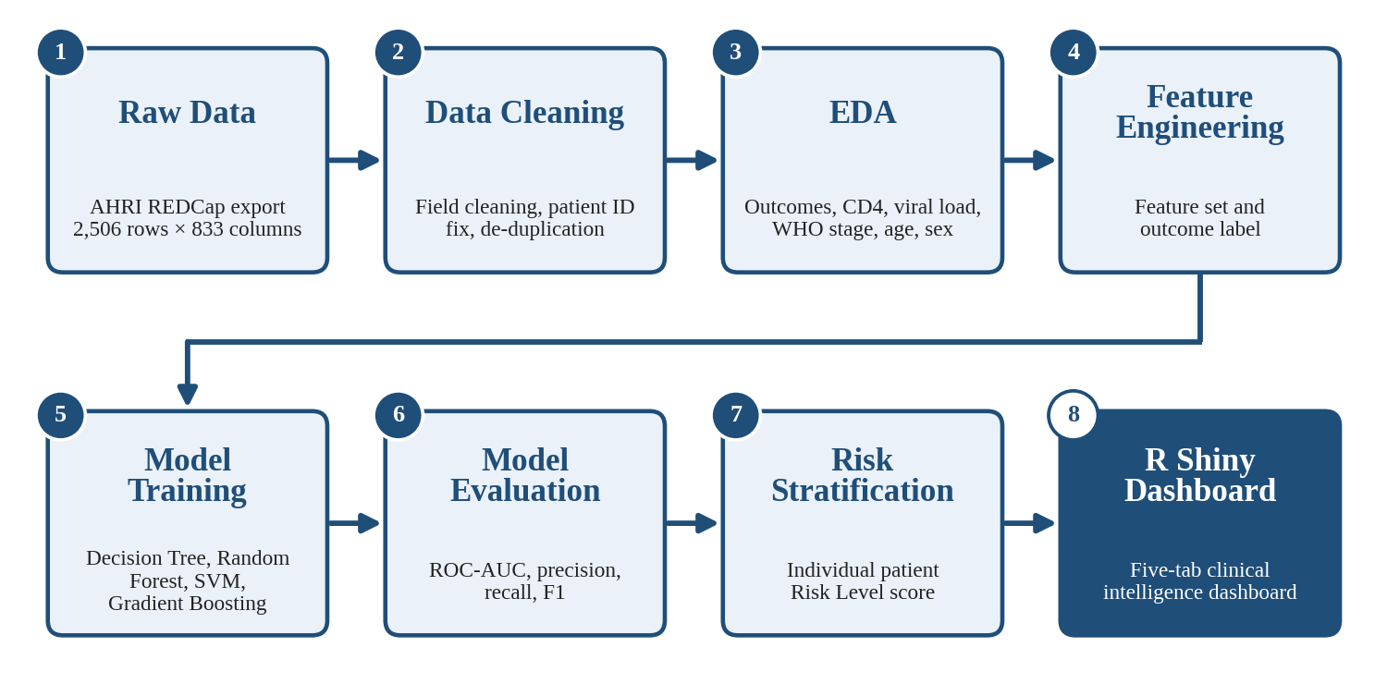
Figure 4.1: Project methodology framework, from the raw AHRI HIV/ART data to the R Shiny dashboard.
The raw data and data cleaning stages (stages 1 and 2) are described in Sections 4.5 and 4.6, exploratory data analysis (stage 3) in Section 4.7, and feature engineering (stage 4) in Section 4.8. Model training and model evaluation (stages 5 and 6) are covered in Sections 4.9 and 4.10. Risk stratification (stage 7) turns the selected model's output into an individual Risk Level score, which is presented alongside the other indicators in the R Shiny dashboard (stage 8) described in Section 4.11. The Python-based analysis and the R-based dashboard were kept consistent by using the same feature logic in both.
4.5 Data Description
Our source data was a REDCap export provided through AHRI's collection of the CEM (HIV/ART) patient cohort. It had four parts: a baseline questionnaire, an ART treatment-start questionnaire, a follow-up questionnaire repeated at later visits, and a pregnancy questionnaire for some female patients. Lab results (CD4, viral load, and 16 other panels such as ALT, AST, creatinine, hematocrit, white blood cell count, and more) were stored as separate columns for each visit instead of as a clean, repeated table.
The raw file had 2,506 rows and 833 columns. Of the roughly 2.09 million individual cells in the file, 1,504,487 (72.1%) were empty, and 121 columns had no data in them at all. We checked the 386 columns that were more than 95% empty and found that most of this was expected, not a mistake: 149 columns were pregnancy or family-planning questions that only apply to some patients, 171 were follow-up questions that only apply to patients with more than one visit, 35 were rare-event flags, and 31 were gaps we could not fully explain. After this check, we narrowed our main working file down to 69 well-populated core columns, while keeping the full lab columns separately for reshaping.
The remaining 31 unexplained gaps deserve a brief note, since we did not simply set them aside once identified. For each of these columns, we checked a small sample of rows by hand against the corresponding REDCap section to see whether the gap reflected a skipped question, a discontinued field, or something else. Most turned out to be fields tied to an earlier version of the questionnaire that had since been replaced, which is a common pattern in long-running research data collection but one that is easy to miss without this kind of manual spot-check.
Our overall workflow followed this sequence: REDCap export (AHRI) → data understanding → data cleaning → patient ID fix and de-duplication → lab result reshaping → exploratory data analysis → feature engineering → model training and comparison → dashboard development → handover to MoH.
4.6 Data Preprocessing
This was the largest part of our work. Below we explain, field by field, what we did. We present these in roughly the order we tackled them, though in practice several ran in parallel once we split the work between us, with regular check-ins to make sure a change in one field's cleaning logic had not quietly broken an assumption another cleaning step depended on. Simplified sample code for the cleaning rules, and a data dictionary for the key cleaned fields, are given in Appendix D.
Lab results. We turned the repeated lab columns into a proper long table, with one row per test. Our first pass on CD4 and viral load alone produced 5,276 test records. CD4 results were split into numeric (2,750), not done (227), undetectable (39), needing manual review (8), and below threshold (2). Viral load results were split into undetectable (1,500), numeric (329), not done (296), below threshold (111), and needing manual review (14). Doing the same for all 18 lab panels gave us 40,268 test records in total. We also flagged a small number of results (3 records, 0.12% of patients) that looked like they might be duplicated or copied between patients, rather than silently deleting them.
Geography (subcity). The subcity field was one of the messiest. We cleaned it in three rounds. The first round matched 1,638 records to a standard list, leaving 465 unmatched. The second round, using better matching rules, raised this to 1,835 matched records. The third and final round sorted the rest into matched (1,835), "unspecified" (217), missing (186), places outside Addis Ababa (155), genuinely unclear cases needing manual review (92), and 21 cases where a different administrative area had been typed into the subcity field by mistake.
Medication. We standardized ART regimen names (for example, 3TC+EFV+TDF) against a fixed list. This improved from 1,376 to 1,398 correctly standardized records out of 2,506, with only 28 records (1.12%) left needing manual review by the end.
WHO clinical stage. We converted stage values written as Roman numerals (I–IV) and as plain numbers into one consistent number from 1 to 4.
Age. The raw age field had 94 different text formats, including fractions like "5 1/2", month-based ages, and values corrupted by spreadsheet date auto-formatting. After cleaning, almost all patients (2,405 of 2,506) had a clean numeric age in years.
Weight, height, and BMI. Weight was usable for 2,415 patients and height for 2,297 patients, after fixing 69 heights that had been entered in meters instead of centimeters. We recalculated BMI ourselves from the cleaned weight and height, rather than trusting the original BMI column, giving a final average BMI of 21.6.
Patient identifiers and duplicates. No single field reliably identified one patient. We built our own patient ID from facility, patient number, age, and sex. This first version found 148 possible duplicate collisions, which we narrowed down, after closer checking, to 28 true duplicate patient records (matching 73–95% of their fields). For each true duplicate pair, we compared every field side by side and kept the more complete row. This left a final, de-duplicated dataset of 2,478 patients.
We treated this step carefully because getting it wrong in either direction causes a real problem: merging two different patients into one would quietly delete a real person from our analysis, while failing to merge a true duplicate would count one patient twice and bias our results. We chose to be conservative — only merging a pair when the evidence was strong — and left anything less certain for manual review.
Working through this as a two-person team gave us a natural second check on these merge decisions: whichever of us had not made the initial call would independently review a sample of the proposed duplicate pairs before we finalized the de-duplication step. In a handful of cases, this caught a pair we had flagged as a likely duplicate but which, on closer joint review, turned out to be two genuinely different patients who happened to share an unusually common combination of facility, age, and sex.
Because lab results were originally stored as separate columns per visit, they also had to be reshaped before any trend could be seen. Of the 2,506 patients, 1,817 had at least one usable CD4 result, and 680 had two or more results allowing a real trend to be computed. Among those 680, 520 (76.5%) showed an improving CD4 trend, 152 (22.4%) showed a decline, and 8 showed no real change.
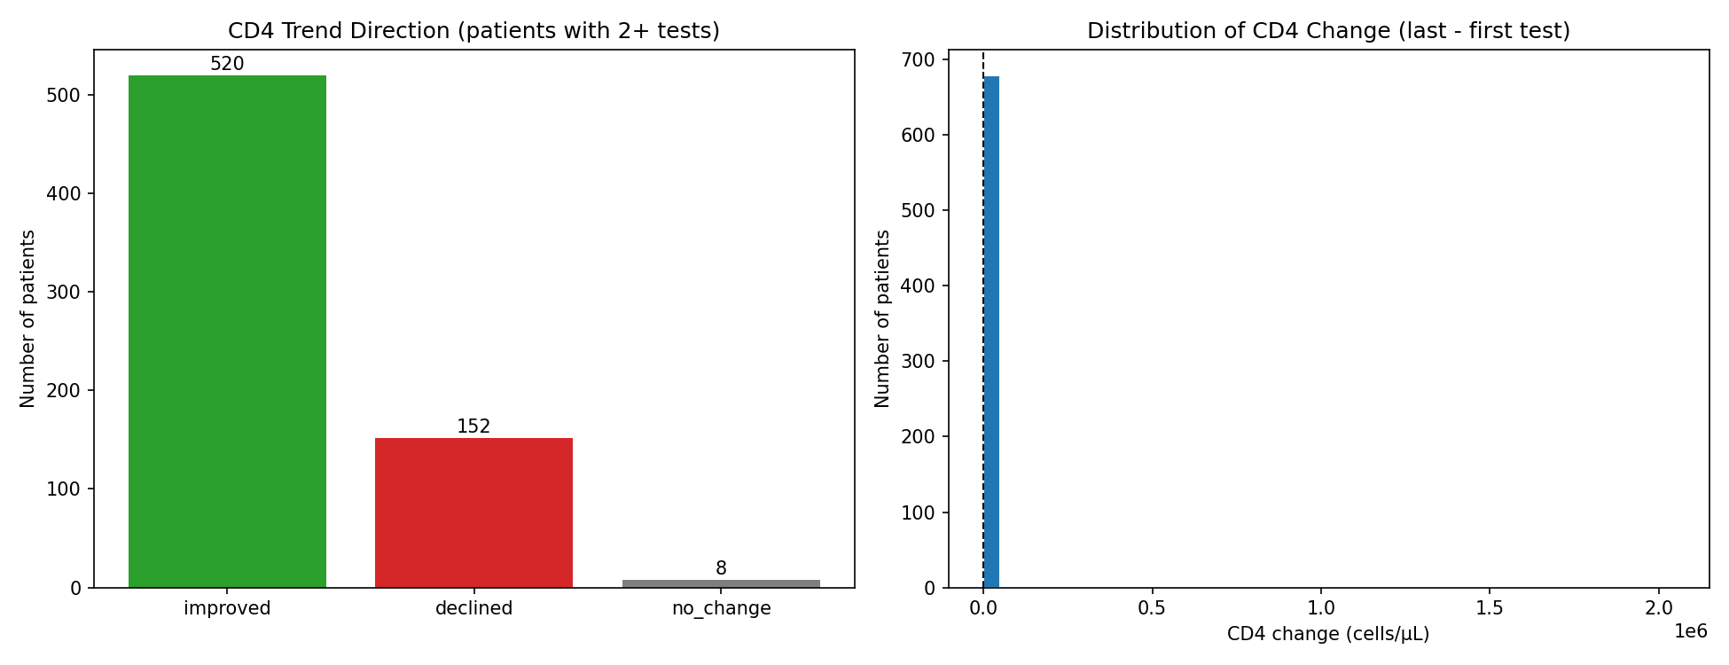
Figure 4.2: CD4 trend direction among the 680 patients with two or more CD4 tests.
We did the same for viral load. Among 1,450 patients with at least one recorded viral load test, the average per-patient suppression rate was 84.3%, and 80.6% of these patients were suppressed on every test we had for them, with suppression rates improving at later visit numbers, getting close to the international 90% target by the fifth and sixth visits.
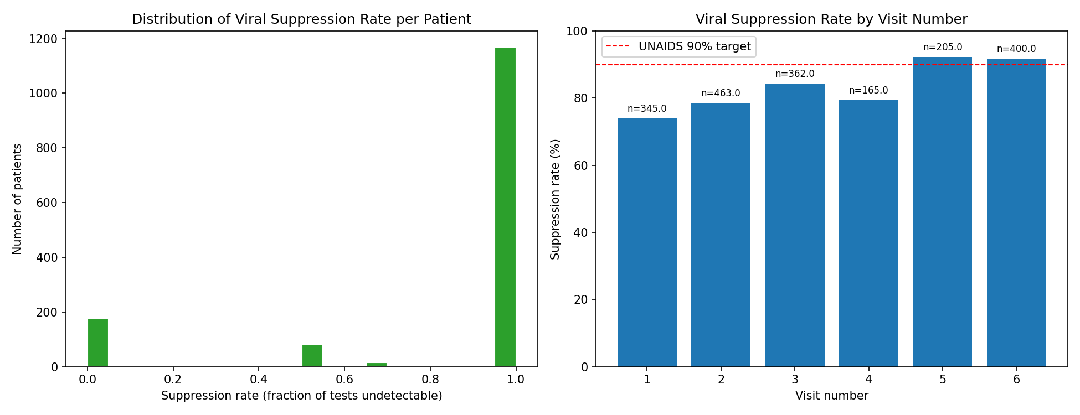
Figure 4.3: Viral load suppression rate per patient (left) and by visit number, compared to the UNAIDS 90% target (right).
4.7 Exploratory Data Analysis
Before finalizing our features, we looked closely at the cleaned data. Out of the full cohort, 1,490 patients (59.5%) were retained in care, 905 (36.1%) were lost to follow-up, and 111 (4.4%) had died (Figure 4.4). The average patient age was 36.3 years, with a median of 35 (Figure 4.5). WHO clinical stage showed a clear pattern: patients at Stage I had an unfavorable-outcome rate of about 34%, rising to close to 49% at Stage IV (Figure 4.6).
We treated this exploratory stage as more than a formality before modeling. Each chart in this section was, in effect, a question we asked of the cleaned data does age differ meaningfully between outcome groups, does WHO stage behave the way clinical knowledge would predict, are male and female patients represented and treated similarly and each answer either confirmed our cleaning had preserved a sensible signal, or flagged something worth double-checking before we trusted it in a model. This step caught, among other things, an early version of the subcity grouping that behaved oddly in a preliminary chart, well before it showed up as a measurable difference in model precision.
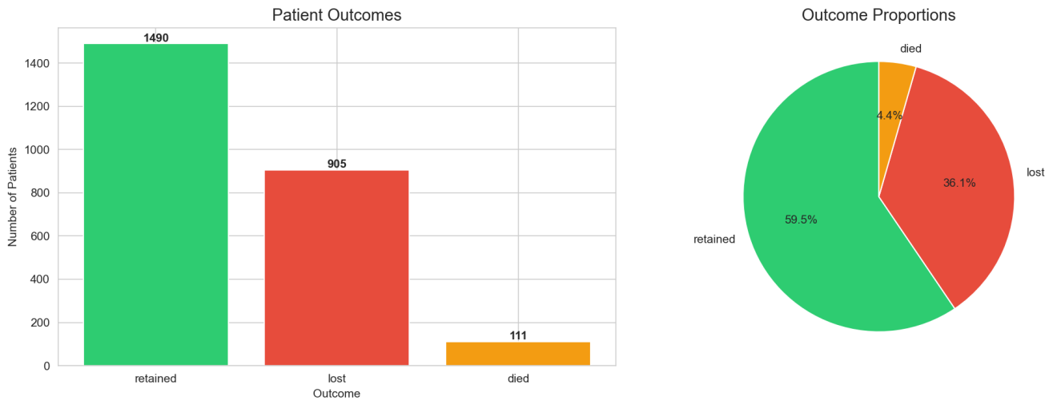
Figure 4.4: Patient outcome distribution across the full cohort: retained, lost to follow-up, and died.
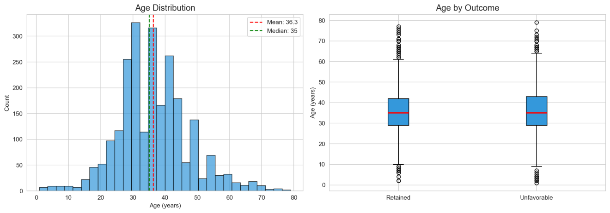
Figure 4.5: Patient age distribution (left) and age compared across retained vs. unfavorable-outcome patients (right).
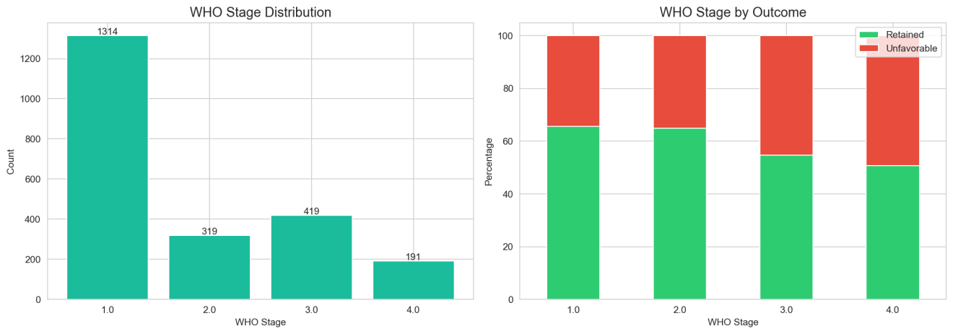
Figure 4.6: WHO clinical stage distribution (left) and unfavorable-outcome rate by stage (right).
We also looked at how the numeric fields relate to each other and to the outcome (Figure 4.7). Weight and BMI were strongly linked (0.83), since BMI is calculated from weight. CD4 and WHO stage were negatively linked (-0.32), consistent with a lower CD4 count usually going with a more advanced WHO stage. None of the numeric fields correlated strongly with the unfavorable-outcome label in a simple straight-line sense, which is why we relied on the Random Forest model's feature importance, not simple correlation, to judge what actually mattered.
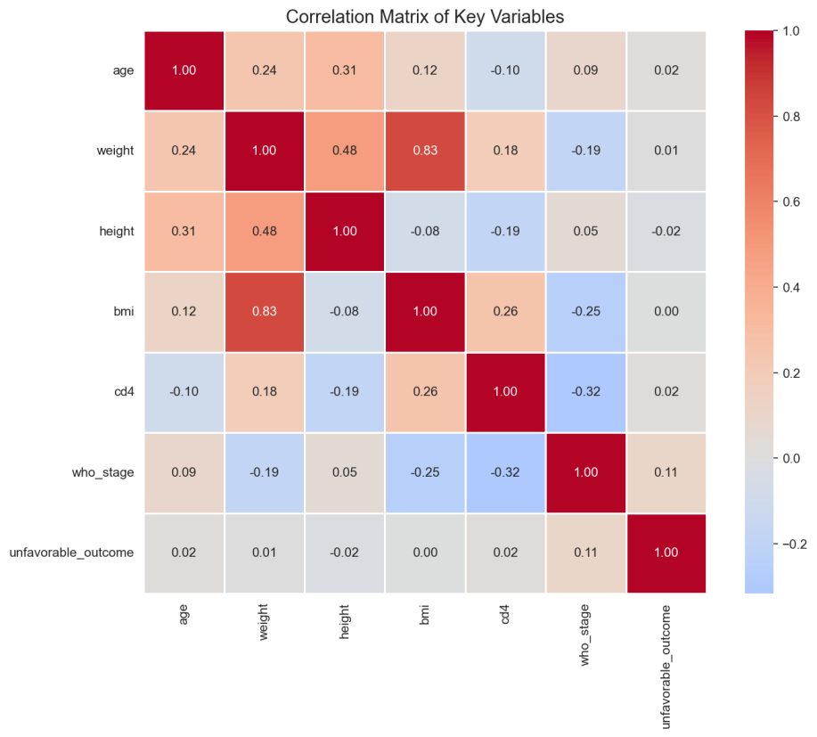
Figure 4.7: Correlation matrix of the main numeric variables, including the unfavorable-outcome label.
We also checked whether outcomes differed by sex (Figure 4.8). The split between male and female patients was fairly balanced, and the unfavorable-outcome rate was similar across both groups.
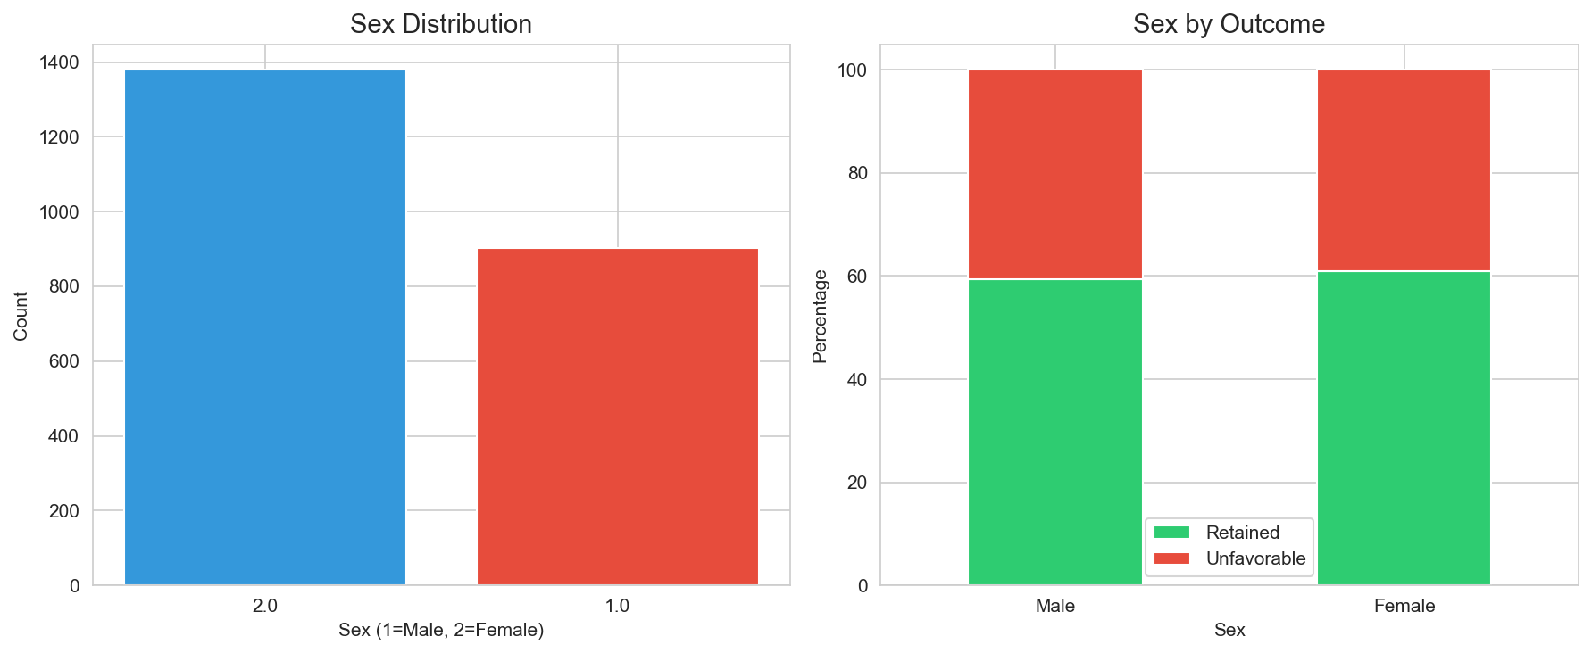
Figure 4.8: Patient sex distribution (left) and outcome by sex (right).
4.8 Feature Engineering
Feature engineering, in our project, meant two related tasks: deciding what to predict, and deciding what information the model would be allowed to use in making that prediction. We treat both together in this section because, in our experience on this project, the two decisions shaped each other the features that made sense depended on how the outcome was defined, and the outcome definition we ultimately settled on was influenced by which features were reliably available.
The outcome target for the predictive model went through one significant revision during the internship. The first modeling pass defined the target narrowly as death, which occurred in 110 of 2,478 patients (4.44%). This rare-event framing made the model difficult to use in practice. Following discussion with our internship supervisor, the target was redefined more broadly as an unfavorable outcome death or loss to follow-up versus retention in active care. This redefinition raised the event rate to 40.72%, producing a far more balanced and actionable target.
The final feature set used across both target formulations is summarized below.
Table 4.1: Feature set used for risk prediction.
Feature | Description | Reason for Inclusion
age_clean | Patient's age, cleaned from messy text values | Older patients tend to carry more risk
sex_label | Patient's sex, standardized from mixed codes | Outcomes can differ by sex
weight_clean / height_clean | Cleaned weight and height | Used to calculate BMI
bmi_recalculated | BMI, calculated fresh from cleaned weight and height | Low BMI often signals poor nutrition and higher risk
baseline_who_stage | WHO clinical stage at the start of treatment (1–4) | A direct measure of how advanced the disease is
baseline_cd4 | First usable CD4 count near the start of treatment | The main lab marker of immune system strength
baseline_vl_status | Viral load status at baseline (detectable/undetectable) | Shows whether treatment is working early on
subcity_grouped | Patient's subcity, cleaned and grouped into 16 categories | Captures differences linked to location and facility access
n_lab_events | How many lab tests the patient has on record | A rough sign of how engaged the patient is with care
days_on_treatment | Days between treatment start and last visit | Shows how long the patient has stayed in care

4.9 Machine Learning Models
Four classification algorithms were trained and compared for both target formulations: Decision Tree, Random Forest, Support Vector Machine (RBF kernel), and Gradient Boosting. The offline analysis was carried out in Python using scikit-learn, with an 80/20 stratified train-test split and 5-fold cross-validation for model selection. The same four algorithms, with matching feature engineering logic, were re-implemented in R (rpart, randomForest, e1071, and gbm) inside the R Shiny dashboard, so the dashboard can retrain and re-evaluate these models live against whatever dataset a user uploads.
Decision Tree was included as an interpretable baseline; Random Forest as an ensemble method expected to handle the mixed numeric/categorical feature set well; SVM (RBF) as a margin-based alternative capable of capturing non-linear boundaries; and Gradient Boosting as a second, typically stronger ensemble method. All models used class-weighting to account for the imbalance present in the death-only target formulation.
We chose this specific set of four models, rather than a longer list, deliberately. Each one represents a genuinely different approach to the same prediction problem — a single interpretable tree, an ensemble of many trees, a margin-based method, and a boosted ensemble — which let us compare not just raw performance numbers but different styles of reasoning about the same data. We considered adding a logistic regression baseline as well, but chose to prioritize depth on four well-tuned models over breadth across a longer, more shallowly explored list, given our nine-week timeline.
4.10 Model Evaluation
On the death-only target (4.44% event rate), results were as follows:
Table 4.2: Model comparison — death-only outcome.
Model | 5-fold CV ROC-AUC | Accuracy | Precision | Recall | F1 | Test ROC-AUC
Decision Tree | 0.776 | 0.778 | 0.114 | 0.591 | 0.191 | 0.749
Random Forest (first version) | 0.825 | 0.921 | 0.242 | 0.364 | 0.291 | 0.798
Random Forest (after fixing subcity grouping) | — | 0.923 | 0.278 | 0.455 | 0.345 | 0.800

Random Forest was the strongest model here. We found and fixed a bug in how we had grouped the subcity feature, which raised precision from 0.242 to 0.278 and F1 from 0.291 to 0.345. Feature importance for the corrected model ranked baseline CD4 first, followed by subcity, days on treatment, and BMI (Figure 4.9).
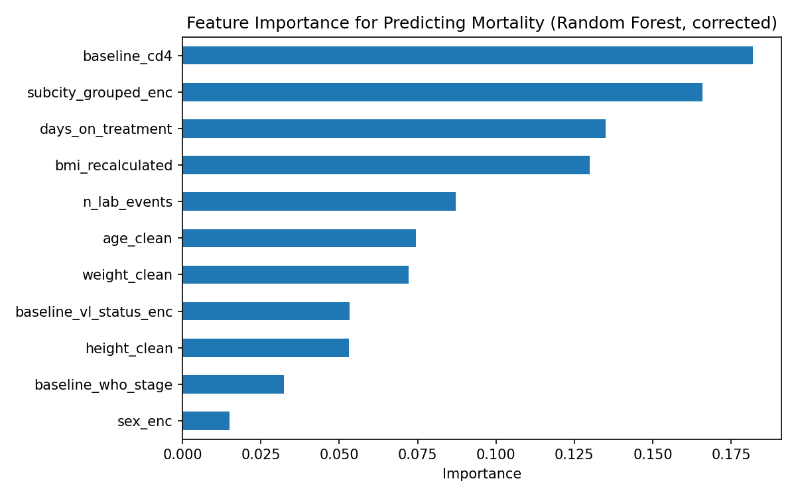
Figure 4.9: Feature importance for the corrected Random Forest model on the death-only outcome.
On the redefined unfavorable-outcome target (40.72% event rate), Random Forest remained the best-performing model:
Table 4.3: Model comparison — unfavorable-outcome target.
Model | CV ROC-AUC | Precision | Recall | F1 | Test ROC-AUC
Random Forest (best model) | — | 0.543 | 0.599 | 0.569 | 0.712

The switch to the unfavorable-outcome target produced a large precision improvement (0.278 → 0.543) at a moderate cost in cross-validated ROC-AUC (0.825 → 0.712) — in plain terms, fewer but far more trustworthy alerts. The full model comparison tables are repeated in Appendix C for quick reference.
4.11 Dashboard Development
Our dashboard was built in R, using shiny, shinydashboard, DT, dplyr, tidyr, stringr, plotly, rpart, randomForest, e1071, gbm, and pROC — chosen specifically to align with the R Shiny tools already used within MoH's digital health environment. It has five sections:
- Executive Summary — cohort-level headline metrics, including overall Retention Status and unfavorable-outcome rate.
- Cohort Explorer — a searchable, filterable table of the cleaned patient data.
- Risk Assessment — trains the four models live on the loaded data and lets a user enter a patient's details (including CD4 and Viral Load) to get an individual Risk Level score.
- Facility Performance — outcome rates and patient numbers broken down by health facility.
- Data Quality — shows how complete the data behind each chart actually is.
Each of these five tabs was designed around a different question a user might have. Executive Summary answers "how is the whole cohort doing right now"; Cohort Explorer answers "let me look at the underlying patients myself"; Risk Assessment answers "what is this specific patient's risk"; Facility Performance answers "which facilities need attention"; and Data Quality answers a question we think is too often skipped in dashboard design "how much should I actually trust what I am looking at." We deliberately kept Data Quality as its own visible tab, rather than a hidden technical detail, because our own experience in Chapter Four convinced us that data completeness is something a dashboard user needs to see directly, not something a dashboard should quietly hide behind a polished-looking chart. A screenshot of the Executive Summary tab is provided in Appendix A.
The dashboard is deployed on shinyapps.io and can be opened at https://rahelgenene.shinyapps.io/cem_deploy/. Its source code (app.R) and the cleaned dataset it reads (CEM_final_preprocessed.csv) are kept in the dashboard folder of our project package, alongside the notebooks and their outputs.
Before treating the dashboard as finished, we tested it in a practical way: we checked that on-screen numbers matched our notebooks, tried filtering by different facilities and subcities, entered several different patient profiles into the Risk Assessment form and checked the risk score moved sensibly, and tried a few unusual inputs to check the dashboard handled them gracefully.
We also asked, deliberately, what a first-time user who had not built the dashboard would find confusing. Working in a team made this easier than it would have been alone: whichever of us had not built a given tab tried using it cold, without explanation, and noted anywhere the layout, labels, or navigation were unclear. This surfaced several small but real problems a filter control with a label too technical for a non-technical user, and a risk score displayed without enough context for a first-time viewer to know whether a given number was good or concerning which we fixed before considering the dashboard finished.
4.12 Results and Discussion
Data Quality Results
We took the dataset from a raw 2,506×833 file, 72.1% empty and with 121 fully empty columns, to a final, usable dataset of 2,478×877.
Table 4.4: Data quality before and after cleaning.
Field | Before Cleaning | After Cleaning
Age | 94 different text formats, including fractions and corrupted dates | 2,405 of 2,506 patients with a clean numeric age
Subcity | Over 130 raw spellings and abbreviations | 16 grouped categories, plus "Other"
ART regimen | Free text, 935 blank, many inconsistent codes | 1,398 standardized, only 28 (1.12%) left for manual review
Patient records | 2,506 rows, patient identity unclear | 2,478 rows, 28 true duplicates removed
BMI | Taken from an existing, sometimes unreliable column | Recalculated from cleaned weight and height for every patient

Facility-Level Findings
Table 4.5: Facility-level unfavorable-outcome rates.
Facility | Patients | Unfavorable-Outcome Rate
St Paul Hospital | 266 | 99.6%
Wereda 3 Health Center | 76 | 100.0%
Gandhi Memorial Hospital | 123 | 43.9%
Police Hospital | 165 | 37.0%
Menelik Hospital | 89 | 25.8%
Kotebe Health Center | 108 | 23.1%
Saries Health Center | 197 | 23.4%
Zewditu Hospital | 235 | 17.4%

Most facilities show unfavorable-outcome rates between roughly 17% and 44%. Two facilities St Paul Hospital and Wereda 3 Health Center show rates of essentially 100%, which we believe reflects a facility-level data-recording pattern rather than a true clinical finding, and which we recommend MoH check directly with these two facilities.
We considered, and rejected, simply removing these two facilities from our facility-level table to avoid an awkward-looking result. We decided against this because doing so would have hidden a genuine data-quality finding behind a cleaner-looking chart exactly the kind of quiet polishing we argue against elsewhere in this report. Instead, we chose to report the number as it is, explain our best interpretation of it, and recommend direct follow-up, which we believe is more useful to MoH than a shorter list of facilities that happens to look more consistent.
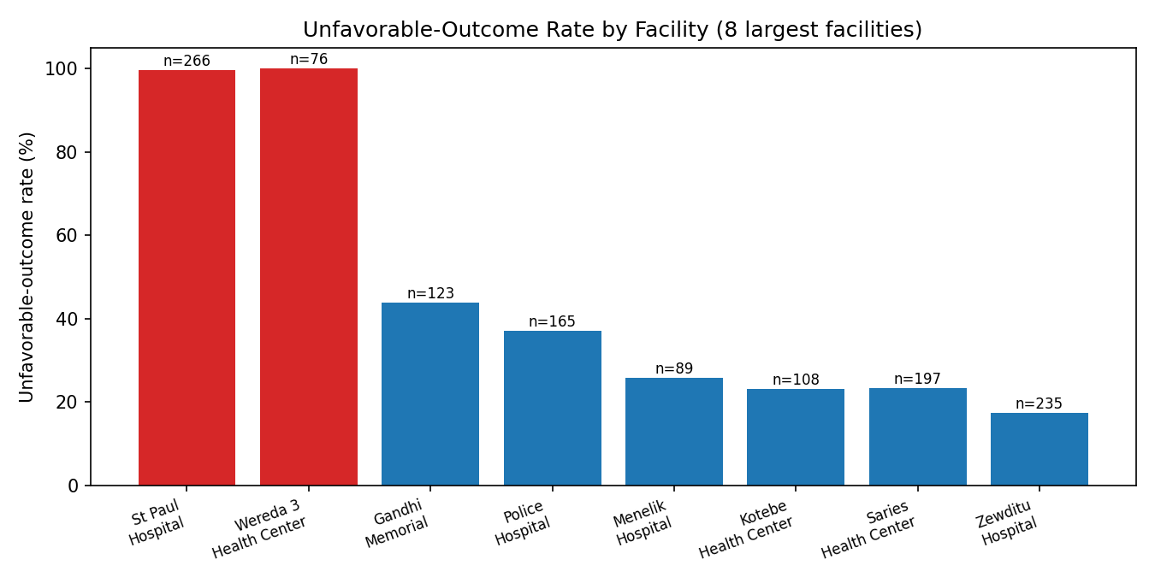
Figure 4.10: Unfavorable-outcome rate by facility. The two facilities shown in red (near 100%) are the ones we believe reflect a data-recording pattern rather than true clinical risk.
Discussion
CD4, subcity, days on treatment, and BMI being the strongest predictors makes clinical sense. A precision of 0.543 on our best model means it is right slightly more than half the time when it flags a patient as high risk useful as a first-pass screening tool, but not accurate enough to be the only basis for a clinical decision. We see this model as something that should support a clinician's judgement, not replace it.
It is also worth comparing our two outcome definitions directly, rather than treating the second as simply "better" than the first. The death-only model, despite its low precision, still achieved a strong cross-validated ROC-AUC (0.825), meaning it was genuinely good at ranking patients by relative risk it simply could not translate that ranking into a small, trustworthy set of alerts, because death was too rare an event. The unfavorable-outcome model gave up some of that ranking power (ROC-AUC 0.712) in exchange for alerts that are right much more often. Which trade-off is preferable depends on how the tool would actually be used: for broad risk stratification across a whole cohort, the first model's ranking ability is valuable; for a short list of patients a busy clinic can realistically follow up on, the second model's precision matters more. We built our dashboard around the second model for this reason, but we think both results are worth reporting together, since they show different things about the same underlying problem.
We also compared our findings against what would be clinically expected in a well-run ART program, as a basic sanity check on our own cleaning process. The improving CD4 trend in most patients with repeat tests, the high overall viral-suppression rate, and the steady rise in unfavorable-outcome rate from WHO Stage I to Stage IV are all consistent with established HIV treatment patterns. Finding results that matched clinical expectation, rather than something surprising or contradictory, gave us more confidence that our extensive cleaning process had preserved the real signal in the data rather than distorting it.
Limitations
Every result in this chapter should be read alongside the limitations below. We list them not to undercut our own findings, but because we believe a results section that omits its limitations is less useful, and less honest, than one that states them plainly alongside what was found. Several of these limitations connect directly to decisions described earlier in this chapter, and we have tried to cross-reference those decisions where relevant.
- Even after cleaning, some fields still have real missing data, which limits confidence for some patients. We chose to leave these as missing rather than guess a value, which is safer but means the model has less information for those patients.
- Our patient ID was built from a combination of fields, not a single trusted ID, so a small number of duplicate or mismatched records may still remain undetected.
- The death-only model's precision (0.278) is still low, because death is genuinely rare in this dataset (110 of 2,478 patients). No amount of further tuning can fully make up for a shortage of real examples to learn from.
- We did not test our model on data from a different time period or set of facilities, so we do not yet know how well it would generalize beyond this specific dataset.
- Our dashboard works on a saved copy of the data, not a live connection to REDCap or MoH's own systems, so the numbers shown will become out of date unless the underlying file is refreshed manually.
- The facility-level finding of near-100% unfavorable-outcome rates at two facilities is, by our own assessment, more likely a data-recording artifact than a true clinical signal, and should not be treated as a finding about those facilities' actual quality of care without further investigation.
Future Improvements
- Connect the cleaning pipeline directly to REDCap so the dashboard can refresh itself with new data automatically, instead of relying on a manual re-export and re-run of the pipeline.
- Use full patient histories (CD4 and viral load trends over time), not just baseline values, since a patient's trend may carry more warning signal than a single snapshot.
- Test the model on a different time period or set of facilities to check that it still performs well outside of the exact data it was trained on.
- Let clinical and program staff try the dashboard and compare its risk scores with their own judgement, and adjust the model or interface based on their feedback.
- Host the dashboard properly within MoH's infrastructure so it can move from a working prototype into a tool used day to day.
- Investigate the two facilities with near-100% unfavorable-outcome rates directly with their staff, to confirm whether this reflects a data-recording pattern rather than a genuine clinical difference.
Chapter Reflection
Reflecting on this chapter as a whole, the technical distance between our raw starting point and our final dashboard is larger than any single section fully conveys. We began with a REDCap export that was, in a real sense, not yet data in any usable meaning of the word — a file that required active interpretation, field by field, before a single chart could be trusted. What we hope this chapter demonstrates is not just a set of individual results, but a coherent, repeatable process for making that kind of transformation: assess before cleaning, clean before modeling, question a result before reporting it, and build the interface last, once the underlying analysis is trustworthy. We believe that process, more than any individual number in this chapter, is the most transferable outcome of our main project.
CHAPTER FIVE: CHALLENGES AND LESSONS
5.1 Data Access Challenges
This chapter brings together the challenges we encountered across the internship, grouped into data access challenges, technical challenges, and the lessons and skills that followed from working through them. We begin with data access, since it was the constraint that shaped almost every other decision described in this report.
Health Data Access Challenges
One of the most significant challenges we faced as a team during this internship was gaining access to real, operational health datasets. Access to real operational health datasets was limited throughout the internship. Health data contains sensitive patient information, and rightly so, authorization and approval processes are required before facility-level or patient-level data can be released for any purpose, including a student project. Data privacy and confidentiality policies further restrict who can access this kind of data, and under what conditions.
Because of these constraints, we used an AHRI HIV/ART dataset for analysis and machine learning development, rather than attempting to work around MoH's access controls or use data we were not authorized to access. We see this as the correct professional response to a real constraint, not merely a workaround: it let us complete a technically substantial, ethically sound project within the time and access we actually had.
We also want to note, for any future intern reading this report, that this constraint was not something we could have negotiated away with more persistence. Even where a request for access was reasonable, the review and approval process required for real patient data takes time that a nine-week internship does not comfortably allow. Recognizing this early rather than spending several of our limited weeks pursuing access that was unlikely to arrive in time was itself an important, practical decision, and it is part of why we recommend, in Chapter Six, that future interns confirm what data will realistically be available before committing to a specific project scope.
It is worth explaining why these restrictions exist, rather than treating them only as an obstacle. Facility-level and patient-level health data can, in the wrong hands, be used to identify individual patients, infer their health status, or track them without consent. The approval processes that slowed our own access to MoH's live systems exist precisely to prevent this kind of harm, and they apply equally to a professional analytics team and to a pair of interns. Understanding this helped us see our own constrained access not as a barrier someone had failed to remove, but as a system working as intended, and it shaped how carefully we in turn handled the AHRI dataset we were given.
Table 5.1: Data access challenges and solutions.
Challenge | Solution We Implemented
Limited access to MoH's operational datasets | Used an appropriately sourced, already-governed AHRI research dataset instead
Sensitive patient information | Worked only with grouped, non-identifying summaries in all outputs and this report
Authorization and approval requirements | Scoped our main project around data we were properly authorized to use from the start
Confidentiality policy restrictions | Did not share raw, patient-level files outside the working environment

5.2 Technical Challenges
Alongside the data access challenges described above, our project also involved a set of purely technical challenges, tied to the condition of the data itself and the tools we used to work with it. We list the most significant ones below, each of which is discussed in more technical detail in the relevant section of Chapter Four.
- Messy source data: ages in many formats, inconsistent lab-result text, and over 130 raw subcity spellings.
- No reliable patient identifier: no single REDCap field was complete and unique on its own.
- A rare, hard-to-predict outcome: the first "died only" target had too few positive cases to learn from well.
- Rebuilding the same logic in two languages: our Python feature-engineering pipeline had to be mirrored carefully in R for the dashboard, with no drift in the numbers between the two versions.
- Learning multiple technologies simultaneously, across DHIS2, KoboToolbox, REDCap, and R Shiny, while also completing a substantial machine learning project.
Each of these technical challenges shared a common root: real health data, and the systems that hold it, are rarely designed around any one analyst's convenience. A field that made perfect sense to a busy clinician entering data quickly at the point of care — a free-text age, a shorthand facility name — is exactly the kind of field that causes the most difficulty downstream. Recognizing this pattern early, rather than treating each messy field as an isolated surprise, made our cleaning work considerably more systematic.
5.3 Lessons Learned
Pulling together everything from Section 5.1 and 5.2, a few lessons stand out as the ones we would pass on first to another student starting a similar internship.
The clearest lesson from this internship is that cleaning and understanding the data is most of the work, not a quick step before the "real" machine learning starts. Decisions made early — like how strict to be about a duplicate patient, or how to group a messy subcity field — shaped everything that came after. Changing our outcome definition was the single most useful decision in the whole project, and it came from a conversation with our internship supervisor, not from a better algorithm.
We also learned, directly, why data access restrictions exist in a health system: patient confidentiality is not an abstract rule but a real constraint that shapes what a project like this can and cannot do, and working around it responsibly — by using an appropriately governed research dataset rather than trying to bypass the restriction — was itself a valuable professional lesson. Working as a team also taught us how to divide technical work sensibly (for example, splitting cleaning tasks by field, or splitting model development from dashboard development) while still keeping our results consistent with each other.
We also learned, more generally, that reporting a weaker result honestly is more valuable than quietly polishing it. Our first "died only" model looked impressive on accuracy alone (92%), and it would have been easy to stop there. Reporting its true precision and recall instead, and then acting on that finding by changing our outcome definition, produced a genuinely better project — a pattern we expect to carry into future data science work, well beyond this internship.
5.4 Skills Acquired
- Real-world health data cleaning at scale, across demographic, clinical, laboratory, geographic, and medication fields.
- Diagnosing and correcting class-imbalance problems in predictive modeling.
- Hands-on exposure to DHIS2, KoboToolbox, and REDCap as digital health platforms used across the sector.
- Building the same analytical pipeline in two programming languages (Python and R).
- R Shiny dashboard development, including live model training.
- Understanding, first-hand, why health data governance and confidentiality practices exist.
- Team-based technical collaboration, including dividing work and keeping results consistent across contributors.
- Communicating a technical trade-off (such as the precision-versus-ROC-AUC trade-off in Chapter Four) clearly enough for a non-technical supervisor to make an informed decision from it.
- Structuring a long, multi-stage project into small, checkpointed steps, each with its own saved output, rather than one continuous, hard-to-debug pipeline.
CHAPTER SIX: CONCLUSION AND RECOMMENDATIONS
6.1 Conclusion
Over nine weeks at the Ministry of Health, Ethiopia, our student team learned how MoH manages its digital health systems, including DHIS2, KoboToolbox, and REDCap, and completed a full data science project using an AHRI-sourced HIV/ART dataset: a cleaned dataset, a working risk-prediction model, and an R Shiny Clinical Intelligence Dashboard aligned with MoH's digital health environment. We met our main objectives: we assessed and cleaned the data, fixed patient identifiers, trained and compared four models under two different outcome definitions, and built a working dashboard presenting Viral Load, CD4, Risk Level, Retention Status, and Facility Performance.
Looking back on the internship as a whole, we think the strongest evidence of what we learned is not any single chart or score, but the number of times we changed our approach after checking our own work honestly: correcting the subcity-grouping bug, and redefining the outcome target after our first model's weak precision made clear that a rare event was not the right thing to predict. As a team, we see that habit of checking, questioning, and revising our own results as the most durable outcome of this internship, more so than any one deliverable.
This internship also confirmed, for both of us, that data science work in a health setting is inseparable from the ethical and organizational constraints around it. Every technical decision we made how to define an outcome, how strict to be about a duplicate patient, what to show in a chart was shaped by the fact that this was real, sensitive information about real people. We finish this internship with a stronger sense of that responsibility than we started with, alongside the technical skills described throughout this report.
Finally, we want to acknowledge, plainly, that nine weeks is a short time relative to the scope of what a fully deployed clinical monitoring system would need. We do not present this report as a finished product, but as a complete, honestly evaluated first version — one that demonstrates the full pipeline from messy raw data to a working, tested dashboard, and that identifies, rather than hides, the specific places where further work is still needed before this tool could be trusted for routine clinical use.
As a closing thought, we want to note that this internship changed how each of us thinks about the phrase "machine learning for healthcare." Before this internship, that phrase suggested, to us, mainly the modeling step choosing an algorithm, tuning it, reporting a score. After nine weeks on this project, we understand it very differently: as a discipline that begins with painstaking, unglamorous data work, is shaped at every step by real ethical and organizational constraints, and only produces something trustworthy when the people building it are willing to report their weaker results as honestly as their stronger ones. We carry that understanding forward from this internship more than any single technical skill.
6.2 Key Achievements
- Cleaned a 2,506-patient, 833-column raw dataset down to a final, usable 2,478×877 dataset.
- Built a reliable composite patient identifier and removed 28 true duplicate patient records.
- Reshaped over 40,000 laboratory test records into a proper longitudinal format for trend analysis.
- Trained and compared four machine learning models under two outcome definitions, improving model precision from 0.278 to 0.543 through a better-defined target.
- Delivered a working R Shiny Clinical Intelligence Dashboard aligned with MoH's digital health environment, presenting Viral Load, CD4, Risk Level, Retention Status, and Facility Performance.
- Gained direct, hands-on exposure to DHIS2, KoboToolbox, REDCap, and R Shiny as digital health tools used across the sector.
6.3 Learning Outcome Reflection
This section evaluates how our skills developed against the learning outcomes expected of the internship, using evidence from the project rather than a list of skills.
Technical knowledge. We moved from coursework exercises to a complete data science pipeline on real data: cleaning a 2,506-patient, 833-column REDCap export into a 2,478×877 dataset, reshaping over 40,000 laboratory records, training and comparing four models, and building an R Shiny dashboard that retrains the models live. Re-implementing the Python pipeline in R, with no drift in the numbers, showed that we could carry the same logic across two languages.
Analytical thinking. We learned to test results against clinical expectation rather than accept them. The improving CD4 trend in most patients with repeat tests and the rising unfavorable-outcome rate from WHO Stage I to Stage IV gave us confidence in the cleaning, while the near-100% rates at two facilities led us to judge them a data-recording pattern and recommend follow-up instead of removing them. Comparing the two outcome definitions taught us to weigh precision against ranking power, not to choose the model with the best single number.
Research and independent learning. We learned DHIS2, KoboToolbox, REDCap, and R Shiny within the same nine weeks. Studying them side by side showed that the right platform depends on whether the priority is national-scale standardization, research-grade data quality, or field-level flexibility.
Communication. We checked in with our internship supervisor after each stage, explained the precision-versus-ROC-AUC trade-off clearly enough for a non-technical supervisor to decide on it, and wrote plain-language labels into the dashboard so that first-time users could follow it. In this report we documented both our original approach and the revised one instead of presenting only the final version.
Teamwork. We divided the cleaning and dashboard work while reviewing each other's decisions, which caught duplicate pairs that were actually different patients and usability problems in tabs the other had built. Agreeing on shared file structure and naming conventions early let us combine our work without conflicts (Appendix F).
Ethics and professional responsibility. We used an appropriately governed AHRI dataset rather than trying to bypass access controls, kept patient-level files inside the working environment, and reported grouped, non-identifying summaries. We described our model as decision support for clinicians and our results as prototype findings that have not been validated for clinical use.
Adaptability. We changed course when the evidence required it: we fixed the subcity-grouping bug, redefined the outcome target after the death-only model's weak precision, and absorbed several new technologies at once while completing a substantial project.
Career readiness. The internship gave us end-to-end experience from a raw export to a tested dashboard inside a national digital health environment, and a clearer picture of how much of health machine learning is careful data work. Areas we still need to develop include testing a model on data from a different period or facility set, working with live production systems, and piloting a tool with clinical users.
6.4 Recommendations
The recommendations below are organized by audience, since a suggestion useful to MoH is not necessarily useful to a future intern or to the university, and we wanted each reader of this report to be able to find the recommendations most relevant to them quickly.
To the Ministry of Health:
- Work with AHRI and other data partners to add simple dropdown choices for fields like subcity, WHO stage, and ART regimen at the point of data entry.
- Set up one single, reliable patient ID at the point of data entry, instead of rebuilding one after the fact from weaker fields.
- Pilot the Risk Assessment tool with a small group of clinical staff before any wider rollout, and collect structured feedback before treating it as a routine tool.
- Investigate the two facilities with near-100% unfavorable-outcome rates directly with their staff, to confirm whether this reflects a data-recording pattern.
- Consider a clearer, faster approval pathway for future student interns to access appropriately anonymized facility-level data, where feasible.
To future interns:
- Plan for data cleaning to take up most of your time — in this project, it did.
- Talk to your supervisor early about what you are predicting and why, before spending a lot of time tuning a model on the wrong target.
- If working in a team, agree early on a shared file structure and naming convention, so that work done separately can be combined without conflicts.
To Debre Berhan University:
- More practice with messy, real-world datasets during coursework would help future students feel less surprised by how much cleaning work a real internship project actually needs.
- More hands-on practice with R alongside Python would help students who go on to work with organizations, like MoH, that already run part of their systems in R.
Each of these recommendations is grounded in a specific, concrete moment from our own project, rather than a general wish. The recommendation about a single reliable patient ID, for example, comes directly from the two weeks we spent reconciling 148 identifier collisions down to 28 confirmed duplicates — time that would have been unnecessary with a better identifier scheme in place from the start. We have tried, throughout this report and in these recommendations, to keep our suggestions tied to something we actually experienced, rather than offering advice in the abstract.
6.5 Future Work
The items below represent what we would prioritize next, if this project continued beyond the internship, ordered roughly from most immediately actionable to most ambitious.
- Explore a formal, privacy-preserving process for connecting our HIV/ART dashboard to MoH's own DHIS2 data, once appropriate approvals and safeguards are in place.
- Extend the risk-prediction approach used here to other patient cohorts and disease programs within MoH's broader digital health portfolio.
- Use full patient histories (CD4 and viral load trends over time), not just baseline values, as inputs to a future version of the model.
- Validate the model against data from a different time period or set of facilities to test how well it generalizes.
- Host the dashboard properly within MoH's infrastructure so it can move from a working prototype to a tool used day to day.
Overall, as a team, we believe the value of this internship was not only the model and dashboard we built, but the pipeline and habits behind them: a clear, step-by-step way of turning messy, real-world health data into something trustworthy enough to build on. We hope MoH finds this work useful as a starting point for wider digital health monitoring.
We also want to close by naming what we think would most improve this specific project if it continued past our internship: closing the loop between the dashboard and the people who would actually use it day to day. Everything in this report, up to and including our own testing in Chapter Four, was still done by the two of us evaluating our own work. The single most valuable next step, in our view, is not a new feature or a better model, but a structured pilot with real clinical and program staff at MoH, whose feedback would tell us far more about whether this tool is actually useful than any additional metric we could compute ourselves.
References
The sources below informed the methods, tools, and background used throughout this report, cited in APA style.
Breiman, L. (2001). Random forests. Machine Learning, 45(1), 5–32.
Harris, P. A., Taylor, R., Thielke, R., Payne, J., Gonzalez, N., & Conde, J. G. (2009). Research electronic data capture (REDCap) — a metadata-driven methodology and workflow process for providing translational research informatics support. Journal of Biomedical Informatics, 42(2), 377–381.
Pedregosa, F., Varoquaux, G., Gramfort, A., Michel, V., Thirion, B., Grisel, O., Blondel, M., Prettenhofer, P., Weiss, R., Dubourg, V., Vanderplas, J., Passos, A., Cournapeau, D., Brucher, M., Perrot, M., & Duchesnay, É. (2011). Scikit-learn: Machine learning in Python. Journal of Machine Learning Research, 12, 2825–2830.
World Health Organization. (2021). Consolidated guidelines on HIV prevention, testing, treatment, service delivery and monitoring: Recommendations for a public health approach. World Health Organization.
Armauer Hansen Research Institute (AHRI). HIV/ART patient cohort data, used with permission from the Ministry of Health, Ethiopia.
HISP / University of Oslo. DHIS2 documentation and platform overview. https://dhis2.org
KoboToolbox. Platform documentation. https://www.kobotoolbox.org
Appendices
Appendix A: Dashboard Screenshots
The screenshot below shows the Executive Summary view of our deployed R Shiny dashboard, live at rahelgenene.shinyapps.io/cem_deploy/. It displays the same cohort-level numbers described in Chapter Four: 2,478 total patients, 110 deaths (4.4% of the cohort), 1,469 patients active in care, and 899 lost to follow-up or inactive, alongside the Program Insights panel, the patient-status breakdown, and the Facility Mortality Ranking table.
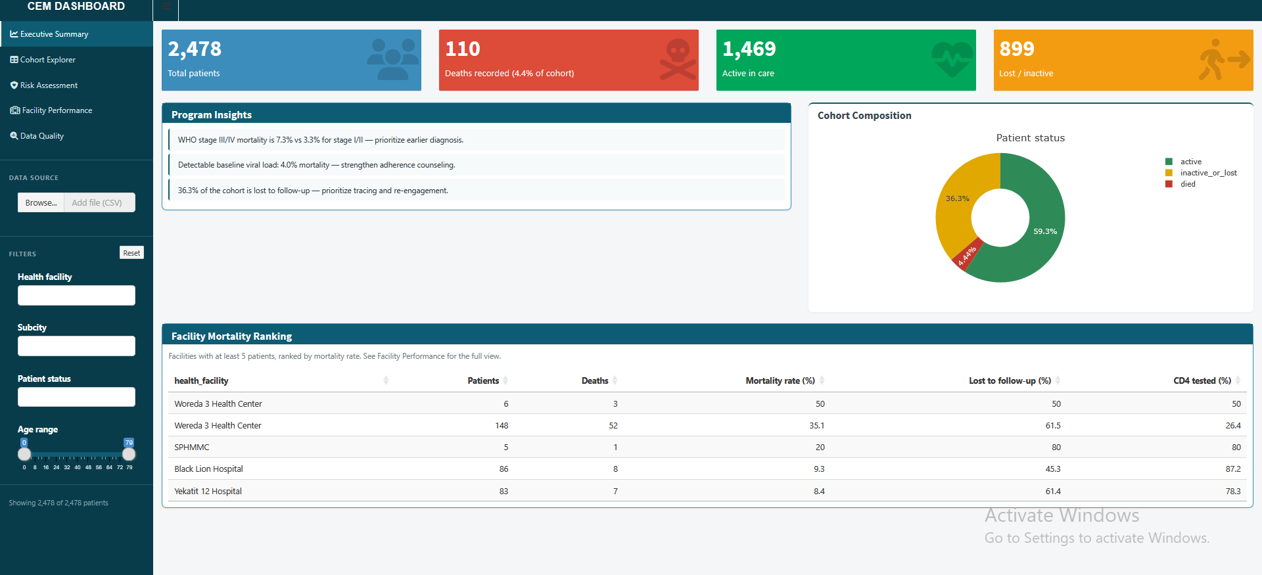
Figure A.1: Executive Summary view of the deployed R Shiny dashboard (rahelgenene.shinyapps.io/cem_deploy/), showing cohort totals, program insights, patient-status composition, and facility mortality ranking.
The dashboard's left-hand panel also includes filters for health facility, subcity, patient status, and age range, and a sidebar navigation menu leading to the Cohort Explorer, Risk Assessment, Facility Performance, and Data Quality tabs described in Section 4.11.
Appendix B: Data Cleaning Workflow
REDCap export (AHRI) → Data understanding → Data cleaning (age, weight, height, BMI, WHO stage, medication, subcity) → Patient ID fix & de-duplication → Lab result reshaping (wide to long) → Exploratory data analysis → Feature engineering → Model training & comparison → Dashboard development.
Each arrow in this workflow represents a saved checkpoint, not just a conceptual step. In practice, this meant a specific named file at the end of each stage — for example, age_cleaned.csv after the age-cleaning step, CEM_deduped.csv after de-duplication, and CEM_final_preprocessed.csv as the final input to modeling and the dashboard. Keeping each stage's output as its own file, rather than modifying one dataset in place, meant that if a later stage revealed a problem with an earlier decision, we could trace it back to the exact file where it was introduced and fix it there, rather than reworking the entire pipeline from scratch.
Appendix C: Model Evaluation Results
These tables repeat the model comparison results already presented in Chapter Four (Section 4.10), collected here for quick reference alongside our other technical appendices.
Death-only outcome (4.44% event rate):
Table C.1: Model comparison — death-only outcome.
Model | 5-fold CV ROC-AUC | Accuracy | Precision | Recall | F1 | Test ROC-AUC
Decision Tree | 0.776 | 0.778 | 0.114 | 0.591 | 0.191 | 0.749
Random Forest (first version) | 0.825 | 0.921 | 0.242 | 0.364 | 0.291 | 0.798
Random Forest (after fixing subcity grouping) | — | 0.923 | 0.278 | 0.455 | 0.345 | 0.800

Unfavorable-outcome target (40.72% event rate):
Table C.2: Model comparison — unfavorable-outcome target.
Model | CV ROC-AUC | Precision | Recall | F1 | Test ROC-AUC
Random Forest (best model) | — | 0.543 | 0.599 | 0.569 | 0.712

Reading these two tables side by side is, in our view, the single most important comparison in this entire report: the same four algorithms, the same cleaned dataset, the same feature set, evaluated against two different definitions of what counts as an outcome worth predicting. The difference in usable precision between them (0.278 versus 0.543) came entirely from that one change in problem definition, not from any change to the models themselves.
Appendix D: Sample Code Snippets
value = uppercase(trim(raw_who_stage))
if value in {"I","II","III","IV"}: return roman_to_number(value)
elif value in {"1","2","3","4"}: return number(value)
else: return missing
The same general pattern — normalize the text, check it against a small set of known valid forms, and fall back to "missing" rather than guessing — was used for age, medication, and subcity cleaning as well. For subcity specifically, the logic added a fuzzy-matching step before the final fallback, since raw subcity spellings varied more widely than WHO stage entries:
value = lowercase(trim(raw_subcity))
if value in known_subcity_list: return standardize(value)
elif fuzzy_match(value, known_subcity_list) > threshold: return best_match
elif value in known_synonyms: return synonym_lookup(value)
else: return "manual_review"
A fuller data dictionary for the key cleaned fields in the final dataset and dashboard is given below.
Table D.1: Sample data dictionary for key cleaned fields.
Column Name | Type | Meaning
patient_id_v3 | Text | Our own reconciled patient identifier, built from facility, patient number, age, and sex
age_clean | Number | Patient age in years, cleaned from raw text
sex_label | Text | Patient sex, standardized from mixed codes
bmi_recalculated | Number | BMI recalculated from cleaned weight and height
baseline_who_stage | Number (1–4) | WHO clinical stage at treatment start
baseline_cd4 | Number | First usable CD4 count near baseline
baseline_vl_status | Category | Baseline viral load status (undetectable/detectable/etc.)
subcity_grouped | Category | Cleaned and grouped subcity (16 categories plus "Other")
n_lab_events | Number | Count of laboratory test events for the patient
days_on_treatment | Number | Days between ART start and last recorded visit
patient_status | Category | Outcome: retained, lost to follow-up, or died
unfavorable_outcome | 0/1 | 1 if died or lost to follow-up, 0 if retained

Appendix E: Internship Schedule
Table E.1: Internship schedule.
Week | Dates | Main Focus
1 | Jun 8–14 | Orientation and getting access to the AHRI dataset
2 | Jun 15–28 | Checking data quality on the raw 2,506×833 file
3 | Jun 29–Jul 12 | Cleaning demographic and clinical fields
4 | Jul 13–21 | Cleaning geography/medication, reshaping lab results, fixing patient IDs
5 | Jul 22–28 | Building the modeling table and the first mortality model
6 | Jul 29–Aug 3 | Full exploratory analysis and changing the outcome target
7 | Aug 4–6 | Building the Python dashboard and then the R Shiny version
8 | Aug 7–8 | Testing, fixing bugs, and writing up results for handover
Appendix F: Team Contribution Summary
As described in Chapter Three, this internship and this report were completed jointly. The table below summarizes each team member's primary areas of focus, though both of us reviewed, tested, and contributed to every part of the final project.
Table F.1: Team contribution summary.
Area of Work | Primary Focus
Data quality assessment and cleaning | Rahel Genene, with joint review
Patient ID reconciliation and de-duplication | Joint work
Feature engineering and outcome definition | Joint work, with internship supervisor input
Machine learning model development (Python) | Rahel Genene, with joint review
R Shiny dashboard development | Hanna Getachw, with joint review
Dashboard testing and usability review | Joint work
Report writing and documentation | Joint work

The table below breaks this down further, week by week, alongside the internship schedule already given in Appendix E.
Table F.2: Weekly primary focus and lead, by team member.
Week | Primary Focus This Week | Lead
1 | Orientation and dataset access | Joint
2 | Data quality assessment | Rahel Genene
3 | Demographic and clinical field cleaning | Rahel Genene
4 | Geography/medication cleaning and patient ID reconciliation | Joint
5 | Modeling table and first mortality model | Rahel Genene
6 | Exploratory analysis and outcome redefinition | Joint
7 | Dashboard development (Python, then R Shiny) | Hanna Getachw
8 | Testing, fixes, and report writing | Joint

Appendix G: Glossary of Terms
- DHIS2 — the national platform MoH uses to collect and report routine health data.
- KoboToolbox — a mobile/web tool for collecting field survey data.
- REDCap — a computer system used to collect and store research and health data.
- CD4 count — a blood test result showing immune system strength.
- Viral load — a blood test result showing the amount of HIV virus in the blood.
- WHO clinical stage — a scale from 1 to 4 describing HIV disease severity.
- BMI (Body Mass Index) — a number calculated from weight and height, used as a simple nutritional check.
- Feature — a piece of information a model uses to make a prediction.
- Outcome / target — the thing a model is trying to predict.
- Precision — out of all the times a model said "high risk", the share of times it was right.
- Recall — out of all patients who had the outcome, the share the model correctly caught.
- ROC-AUC — a score (0–1) showing how well a model separates two outcome groups.
- Random Forest — a model that combines many smaller decision trees to make one final prediction.

